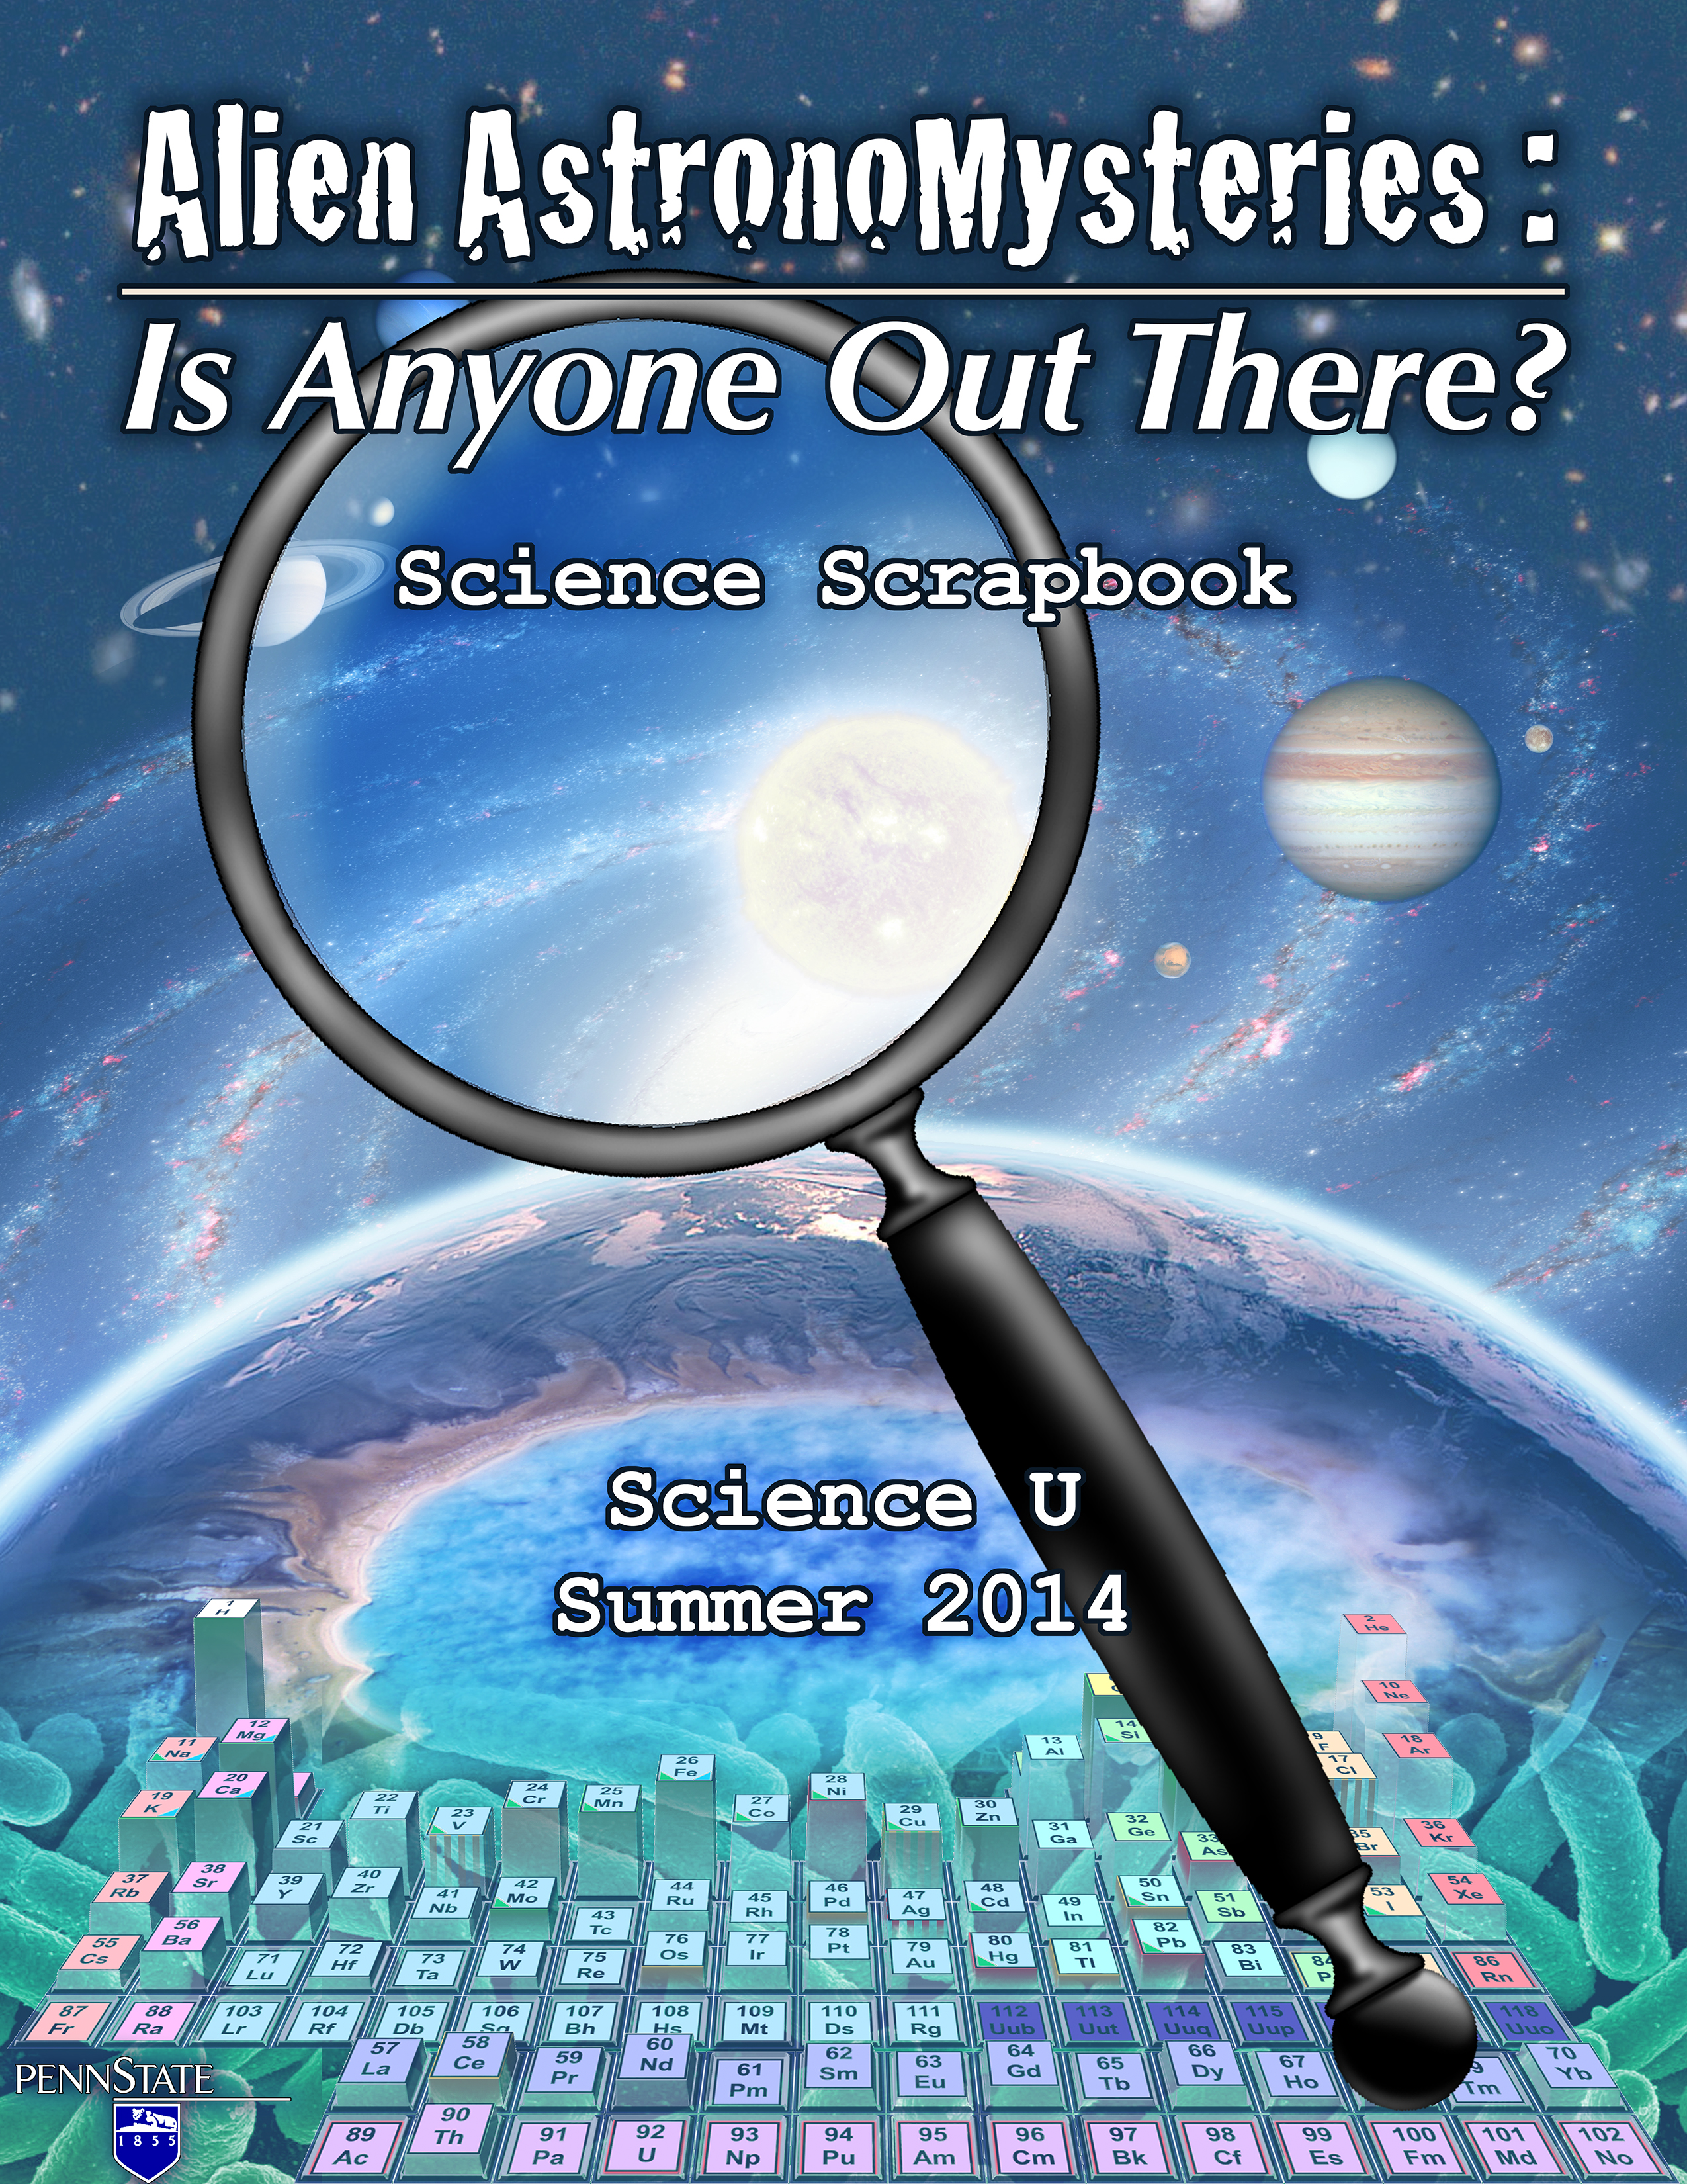
Alien AstronoMysteries
Science Scrapbook
This is the property of:

_____________________________________________
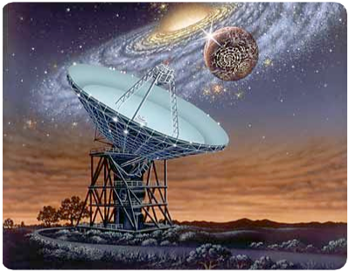
Alien AstronoMysteries
Guess
Have fun this week!
Welcome!
We Are science Detectives

Key Questions:

Why aren’t there aliens all around us like on TV or in the movies?

Are we alone?
Welcome to Alien AstronoMysteries!

This week we will be science detectives, exploring the cosmos around us in our quest to
answer one of our greatest questions: are we alone? Every day we will investigate a different topic in astrobiology, the study of life the universe.

We have a lot to learn, from the nature of life, to the worlds of our solar system and beyond, to communicating between the stars. All great scientists diligently record their observations, experiments, and results. This Science Scrapbook is your place to record your observations, your thoughts, and your experiments. They are all clues you can use to answer the Alien AstronoMystery.

Have a great time!

Alien AstronoMysteries
Key Questions:

Scientists work in teams. What’s yours?

Can you design a team logo and camp astrocredits?
What are some of your favorite things (TV show or movie, book, sport to play, etc.)?
What’s your team all about?
1.1: Team extreme
What is your team name? _________________________________



Design your team logo!

You can test out some ideas here
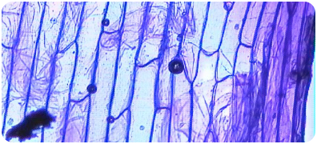
Alien AstronoMysteries
Key Questions:

How do we define life?

What does life do and what does it need to survive?
What defines life? What does it need, and what does it use? Discuss with your team and list the characteristics of life below:
What makes something alive?
1.2: What is life?
The characteristics of life

Life: 20 Questions (or fewer)

Your group has a picture of : ______________________
What questions can you ask the other teams to determine what they have is alive or not?
What have we learned? What does life need, and what does it do?
1
2
3
4
5
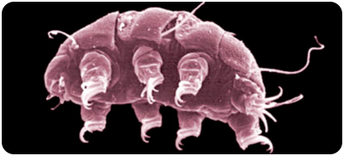
Alien AstronoMysteries
Key Questions:

How abundant and versatile are microscopic forms of life?

What are extremophiles?
Our alien neighbors may look like this
1.3: The Microbe Museum
Station 1 Notes

The Microbe Museum:Station 2

Station 2 Sketches
Station 2 Notes
Magnification:_______X
Magnification:_______X
Station 3 Sketches
Station 3 Notes
Magnification:_______X
Magnification:_______X
The Microbe Museum:Station 3

Station 4 Sketches
Station 4 Notes
Magnification:_______X
Magnification:_______X
The Microbe Museum:Station 4

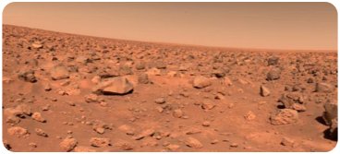
Alien AstronoMysteries
Key Questions:

How can we look for life on other planets?

Is this an easy task to accomplish?
Mars as seen by the Viking landers
1.3: Looking for life on Mars
How would you hunt for life on a distant, desolate world like Mars? What if you only had enough room on your lander to store a small amount of lightweight equipment?
You know what life is and what life needs. What would you do?
Plenary Session
Experiment!

Scientist 1: Measure 2 Tbsp. of a soil sample into your carrying dish and write down which sample number you are using.
Scientist 2: Connect the rubber tube to one end of the glass tube.
Scientist 3: Fill a water tub halfway with warm water.
Scientists 4 and 5: Place the stopper-tube assembly and the graduated cylinder underwater in the tub. Let any air bubbles escape. While the equipment is still under water, insert the rubber tube 10 cm up into the mouth of the graduated cylinder. Be careful to keep the rubber tube in the graduated cylinder and the mouth of the graduated cylinder underwater throughout the entire experiment.
Raise the base of the graduated cylinder until it is inverted (held upside down). Trapped air should be much less than 5 ml; if there is too much trapped air, repeat the procedure.
Scientist 4: Continue holding the graduated cylinder and the rubber tube in place.
Scientist 1: you will keep track of timing.
Scientist 2: You will take readings. Take an initial reading of the graduated cylinder by lowering your eye level to the reading level.
Scientist 3: you will pour 200 ml of hot nutrient solution into the Erlenmeyer flask and hold the flask on the bottom of the tub. As quickly as possible you will pour the soil flask and seal the flask with the stopper end of the stopper- tube assembly.
Scientist 5: you will record all readings. Measurements should be made at 30-second intervals. After three minutes, change the reading interval to every minute instead of every half minute. Stop taking readings after 7 minutes.
All scientists: copy the readings that scientist 4 took. Sketch a graph of your results.
Repeat the procedure for the other soil sample, and switch roles.
look for life on mars!
Erlenmeyer flask
Graduated cylinder
Water tub
Rubber tube
Stopper and glass tube
Sample 1Timemeasurement0 s30 s1 min1 min 30 s2 min2 min 30 s3 min3 min 30 s4 min4 min 30 s5 min5 min 30 s6 min6 min 30 s7 min
Sample 2Timemeasurement0 s30 s1 min1 min 30 s2 min2 min 30 s3 min3 min 30 s4 min4 min 30 s5 min5 min 30 s6 min6 min 30 s7 min

Graph it!

Sample 1
Time
Amount of gas
Sample 2
Time
Amount of gas
Which sample has life? How can you tell?
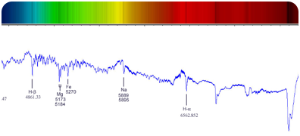
Alien AstronoMysteries
Key Questions:

How can we tell what stars and the atmospheres of distant worlds are made of?

How can we use this knowledge to look for life?
Guess
Spectroscopy: like the skittles of astronomy
1.5: Looking for life across the stars
Guess the element!

Answer
1
2
3
4
1
2
3
4
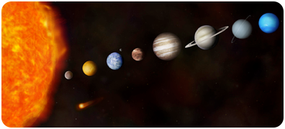
Alien AstronoMysteries
Key Questions:

How far apart are the planets in our solar system?

Would it be easy to get to them?
Are planets in our solar system farther apart than you expected? How long does it take to travel to them?
What’s wrong with this picture?
2.1: the scale of the solar system
Planets around other stars are much, much further away than that. Do you think this may help explain why we haven’t been visited or contacted? Why?
Plenary Session
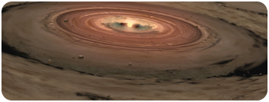


Alien AstronoMysteries
Key Questions:

Can you model how our solar system formed?

Should all solar systems be the same?
How do you make a solar system out of this?
2.2: make your own solar system
The recipe

Ingredients:
Clear, large round bowl with flat bottom (glass pie pan)
Water to fill bowl 1/2 to 2/3 full
1 heaping tablespoon of dried rolled oats (not instant oats)
2 heaping tablespoons of puffed rice cereal
Pinch of black tea

Directions:
Begin stirring water quickly and evenly. Stop stirring after a few moments.
Quickly sprinkle oats and puffed rice into water.
Quickly sprinkle tea into water.

Before
After
DEMO
DEMO
Your turn!

What do the different ingredients represent?
Oats and puffed rice enter water
Tea enters water
End result
Are the other groups’ results similar or different than yours?
Do you think all solar systems will look about the same?
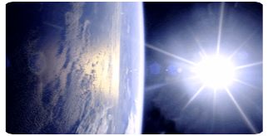
Alien AstronoMysteries
Key Questions:

What is habitability?

What does it depend on?
Record your model atmosphere data here:
Why is the Earth so awesome?
2.3: Habitability and the solar system
atmospheres: global greenhouses

What kinds of “atmospheres” had the greatest greenhouse effect (colored glass and contents)?
BEFORE:

Time of measurement: _____

Temperature: _____

Control Temperature: _____
AFTER:

Time of measurement: _____

Temperature: _____

Control Temperature: _____

Time of measurement: _____

Color of glass: _____

Describe contents: _________________________________
investigate habitability!

Station 1 Notes
Station 2 Notes
Station 3 Notes
Station 4 Notes
investigate habitability!

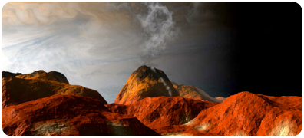
Alien AstronoMysteries
Your group will determine the habitability of:

________________________
Can aliens exist on places like Io?
2.4: Life in the solar system
Explore!

Take a look at all the resources available to you.
What are you going to say? Organize your thoughts here.
Key Questions:

What are the other planets and moons of our solar system like?

Are any of them suitable for any kind of life?
Could there be life anywhere in the solar system besides Earth? If so, could it be complex and intelligent?
Alien AstronoMysteries
2.5: extremophiles: life on the edge
Game break!

Alien AstronoMysteries
Key Questions:

How do the properties of stars vary?

What kinds of stars would be best places to find planets with complex life?
3.1: A stellar family portrait
What does our completed stellar family portrait look like?
Sketch!

What kinds of stars should be the best hosts for habitable worlds and intelligent life?

Alien AstronoMysteries
Key Questions:

How are stars born, how do they live, and how do they die?

How do these life stages vary?
3.2: Stellar evolution in action
Sketch!

Evolution of a low-mass star
Evolution of a high-mass star
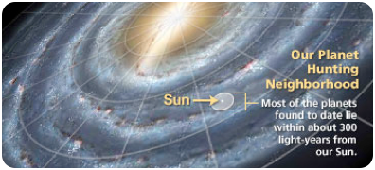
Fill in the blanks:
Betelgeuse is ____ light-years away. It would therefore take ____ years for a message to get from here to there.
Alien AstronoMysteries
Key Questions:

What is the Milky Way? How many stars are there?

How hard would it be to travel between the stars?
Do you think it should be easy to travel or communicate between the stars? Why or why not?
There’s a lot of uncovered territory!
3.3: The Milky Way Galaxy
3D tour of the galaxy
Alien AstronoMysteries
3.4: Astrobiology Jeopardy
Game break!
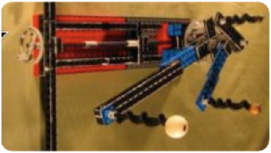
Alien AstronoMysteries
Key Questions:

What’s one way to find planets around other stars?

What can we find out about them?
Orrery: a model solar system
4.1: Detecting exoplanets
Investigate!

Write down your measurements from the light meter (LM) at each position for different beads (planets).
lamp
LM
Top view:
Pos 1
Pos 2
Pos 3
Pos 4
Pos 5
Pos 6
Pos 7
Pos 8
Bead 3
Bead 2
Bead 1
PositionMeasurement12345678
PositionMeasurement12345678
PositionMeasurement12345678
Graph it!
Bead 1
Position
Apparent Brightness
Bead 2
Position
Apparent Brightness
Bead 3
Position
Apparent Brightness
Kepler’s third law
How do we get a planet’s distance from its period?
The lego orrery

How can you tell a planet’s size from the light curve?
How can you tell what planet is closest to the star?
How can you tell how many planets there are?
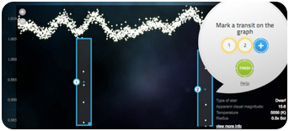
Alien AstronoMysteries
Key Questions:

What do real Kepler data look like?

How easy is it to find exoplanets many light-years away?
What was it like finding real exoplanet candidates? Was it different or similar to what you expected?
Actual data from Kepler!
4.2: hunting for exoplanets
How many planets did everyone find? ______
You? _____
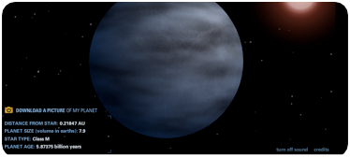
Alien AstronoMysteries
Key Questions:

How can we determine the mass and temperature of exoplanets?

Are there exoplanets that could be habitable?
What happens when you take the Earth and change:
4.3: Are exoplanets habitable?
Extreme planet makeover

Its distance from the Sun?
Its size?
The Sun?
Challenge: Can you make a planet that looks like Earth, but with a different Sun, size, and distance?
Kepler Exoplanet Transit hunt

Work with your group to uncover the hidden properties of as many planets as you can.
Would you want to live on any of them?
What would you look for in a light curve if you wanted to find an Earth-like extrasolar planet?
Alien AstronoMysteries
4.4: Nebular Sharks and Minnows
Game break!
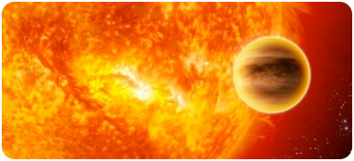
Alien AstronoMysteries
Key Questions:

What kind of solar system is ideal for the evolution of complex life?

Can you build radically different solar systems? What happens to them?
What should we look for in our ideal solar system? What should the orbit of an ideal world be like?
This might not be the best place to live
4.5: what solar systems “work?”
Explore! what kinds of systems can you make?


Describe! What happens?
Sketch! What happens?
________________________________________________________________________________________________________________________________________________________________________________________________________________________________________________________
________________________________________________________________________________________________________________________________________________________________________________________________________________________________________________________
________________________________________________________________________________________________________________________________________________________________________________________________________________________________________________________
Describe! What happens?
Sketch! What happens?
________________________________________________________________________________________________________________________________________________________________________________________________________________________________________________________
________________________________________________________________________________________________________________________________________________________________________________________________________________________________________________________
________________________________________________________________________________________________________________________________________________________________________________________________________________________________________________________
Describe! What happens?
Sketch! What happens?
________________________________________________________________________________________________________________________________________________________________________________________________________________________________________________________
________________________________________________________________________________________________________________________________________________________________________________________________________________________________________________________
________________________________________________________________________________________________________________________________________________________________________________________________________________________________________________________
Describe! What happens?
Sketch! What happens?
________________________________________________________________________________________________________________________________________________________________________________________________________________________________________________________
What do you think?

What kind of solar system is the “best” for developing an advanced civilization? How common do you think this is?
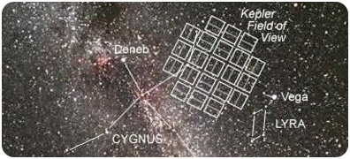
Alien AstronoMysteries
Key Questions:

To whom should we send a message?

What is this distant planet like?
Based on your measurements, what is the best place to which we should send a message?
Which one of these stars will it be?
4.6: who should we talk to?
Predict!

system% brightness dropPeriod (days)12345678910
By a popular vote, what system will we try to contact? What do we know about it?
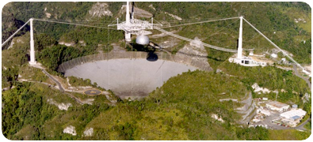
Fill in the blanks:
Our target system is ____ light-years away. It would therefore take ____ years for a message to get from here to there.
Alien AstronoMysteries
Key Questions:
Can you translate a message from outer space?

How would we talk to another civilization?
What are the problems in communicating with an extraterrestrial civilization? How can we deal with them?
The Arecibo radio telescope in Puerto Rico
5.1: Communicating Across the Galaxy


What have you learned?
Practice Message

Tape original message here
Tape deciphered message here
What could it mean?
The Mystery message
A sketch of the message
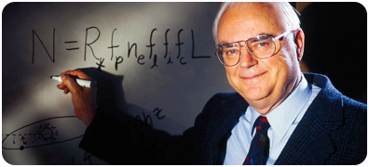
Alien AstronoMysteries
Key Questions:

Can you answer the AstronoMystery?

How can we estimate the number of extraterrestrial civilizations in the Galaxy?
What have we learned so far that would help explain the absence of aliens around us? Do you think there should be aliens around us? Why?
Astronomer Frank Drake
5.2: Are we really alone?
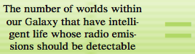
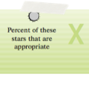
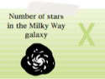
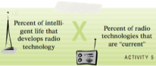
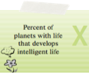
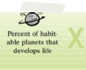
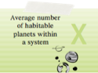
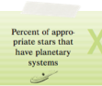
The Drake Equation
Day 3
Day 2-4
Day 1
Day 1-2
?
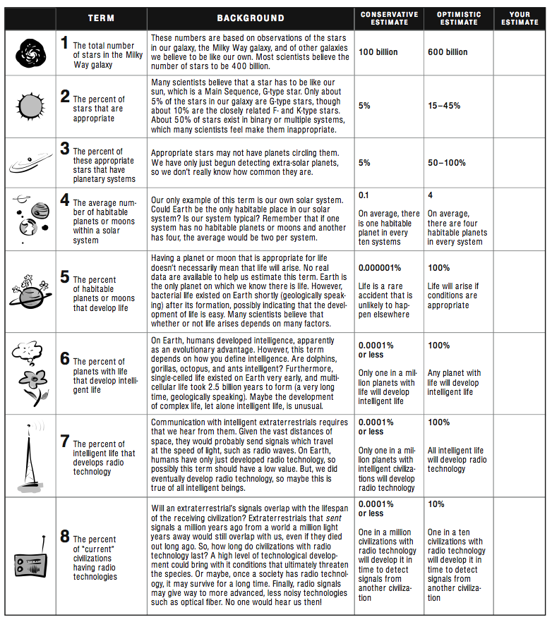
Estimate!
How many civilizations?
Do you expect to hear from them or see them anytime soon?
Class average: ______
Your estimate: _____
The Astronomystery
So what’s your answer?
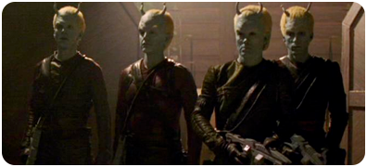
Alien AstronoMysteries
Key Questions:

What could life on another planet we detected be like?

What could its inhabitants look like?
Based on what we know of our target world, what do you think it looks like? What do you think its inhabitants could look like?
Probably not them
5.3: who are we talking to?
Plenary Session


alien Sketch pad
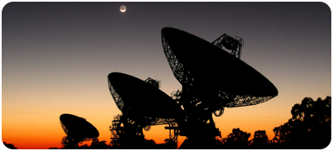
Alien AstronoMysteries
Key Questions:

What should we say to a possible civilization?

How should we say it?
So what shall we say, and how should we say it?
Yours will be the first intended message since 1974!
5.4: interstellar pen pals
Some people think we should avoid drawing attention to ourselves. What do you think?
Greetings from earth!
Our camp message
Your message
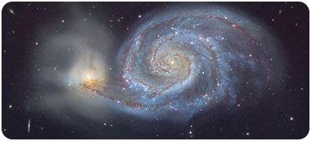
Alien AstronoMysteries
Your group will talk about: MonTueWedThuFriAstronoMystery
Hope you had fun!
5.5: the awards ceremony
What are you going to say?
Key Questions:

What have we learned this week?

What is our answer to the AstronoMystery?
Continued if you need it...

