Alien AstronoMysteries:

Where is Everybody?

Summer 2014

Instructor Manual

Ravi Kopparapu

Camp Director
Table of Contents

Opening Ceremony 2

Day 1: What is Life, and How Do We Find It? 2

1.1: Team Extreme 2

1.2: What is Life? 2

1.3: The Microbe Museum 2

1.3.1: Station 1: Microscopic Life 2

1.3.2: Station 2: Thermophiles 2

1.3.3: Station 3: Tardigrades 2

1.3.4: Station 4: Alien Safari 2

1.4: Looking for Life on Mars 2

1.5: Looking for Life Across the Stars 2

Day 2: Life and Our Solar System 2

2.1: The Scale of the Solar System 2

2.2: Make Your Own Solar System 2

2.3: Habitability and the Solar System 2

2.3.1: Atmospheres: Global Greenhouses 2

2.3.2-1: Station 1: The Habitable Zone 2

2.3.2-2: Station 2: Cratering Through Time 2

2.3.2-3: Station 3: Building Comets 2

2.3.2-4: Station 4: Mars in 3D 2

2.3.2-5: Station 5: Life Under Pressure 3

2.4: Life in the Solar System 3

2.5: Extremophiles: Life on the Edge 3

Day 3: Stars in the Milky Way 3

3.0: Introduction 3

3.1: A Stellar Family Portrait 3

3.2: Stellar Evolution in Action 3

3.3: The Milky Way Galaxy 3

3.4: Astrobiology Jeopardy 3

Day 4: Hunting for Distant Worlds 3

4.1: Detecting Exoplanets 3

4.2: Hunting for Exoplanets 3

4.3: Are Exoplanets Habitable? 3

4.4: Nebular Sharks and Minnows 3

4.5: What Solar Systems “Work?” 3

4.6: Who should we talk to?” 3

Day 5: Life in the Universe 3

5.1: Communicating Across the Galaxy 3

5.2: The Drake Equation 3

5.3: Who are We Talking to? 3

5.4: Interstellar Pen Pals 3

5.5: Awards Ceremony 4

Nighttime Observations 4

Opening Ceremony

Objective
The instructor begins to outline the camp and is interrupted by an incoming message from somewhere from outer space.
- An overview of the camp is provided: general format, astrocredits and prizes, etc.
- The camp purpose dramatically and suddenly shifts with the arrival of the mystery message

Materials
For the instructor:
- laptop and access to computer projector equipment; keynote of intro
For acting talent:
- comical appearance (lab coat, disheveled hair, etc.)
- large linear printout of the mystery message
- recording of mystery message
For each student:
- Lanyard with name card and group number assignment in back

Classroom action (30 min)
- The Camp (15 min). Introduce Alien AstronoMysteries. Points to mention:
- Where are the aliens? Compare to science fiction.
- Original purpose of camp: explain difference between science fiction and reality
- Approach: campers are science detectives. Every day will be an exploration of different topics related to astrobiology, the study of life in the universe.
- To make this fun, we’ll have a big prize at the end (Galileoscopes, but keep it secret), and the opportunity to earn Astrocredits. These can be returned for additional prizes at the end.
- The Mystery Message (15 min). The actor/actress rushes into the room and declares that SETI had an incoming radio signal from somewhere in outer space last night (eastern time; the small radio dish couldn’t pinpoint the exact location). The recording is played and the message printout is shown. Improv the conversation appropriately.
- New mission of the camp: Figure out where this message came from, if it could be from an alien civilization, figure out what it could mean and reply appropriately with our laser transmitter.

Day 1: What is Life, and How Do We Find It?

Introduction
Before we look to the stars for our cosmic neighbors, we need to first understand what life is, the forms it often takes, and what it needs to survive. This will help us narrow our search for it among the menagerie of planets and environments the Universe offers us. It will also help us determine the validity of the mystery message.
As scientists and detectives, we also often work in groups, and teamwork is paramount. Before we embark on our mission, we must first introduce ourselves and meet our teammates for this week’s Alien AstronoMysteries.
1.1: Students will build camaraderie with their teammates and formulate team identities.
1.2: Students will investigate what life is in a modified “20 questions” style game and motivate a definition for life
1.3: Students will examine many aspects of the microscopic domain -- simple organisms and extremophiles in the Microbe Museum
1.4: Students simulate the Mars Viking experiment to detect life on another world
1.5: Students will assess the spectra of several elements and chlorophyll to appreciate how astronomers can detect the elements of life in distant worlds.

1.1: Team Extreme

Overview
Students meet their teammates and develop a group identity
- Students will design team logos they will place on tagboard placeholders.

Materials
For the instructor:
For each team
- art paper
- markers
- colored pencils
- team logo placeholder
- glue
For each student:
- Lab book
- pencils

Classroom action (45 min)
- Introduce (5 min). Direct students to tables based on numbers that are in their lanyards. These are their new teams. With the exception of a few activities, students will be experiencing the camp with their teammates. Introduce their mentors, who will help them throughout the week. Explain their tasks for the remaining time:
- Group identity (remaining time). Who are these teams? What are they about? Have the students introduce themselves and formulate a team identity.
- Favorites. Students will share and list favorite things (include mentor). Suggestions:
  - color
  - movie, TV show, and book
  - food
  - vacation spot or place to be
  - sport or activity
- Students will also come up with a team name.
- Team name and logo. Have students use the art supplies to collectively design a logo for their team. What will their team be called?

1.2: What is Life?

Overview
Students motivate a definition (list of characteristics) of life
- Students will brainstorm the characteristics of life
- Students will play a modified 20 questions-style game to try out their definitions on other teams

Materials
For the instructor:
- large paper for discussion
- markers
For each team
- Alive or not? cards (see allocation below)
For each student:
- Lab book
- pencils

Classroom action (45 min)
- Brainstorm (10 min). Before we try to hunt for life in the universe, we need to first understand what life is. Since we have not other examples besides what we find of Earth, the life we see around us will have to do. Encourage students to brainstorm the characteristics of life. What does life need? What does it do?
- Life: 20 Questions (25 min). Present the Alive or not? cards to each team:
Team | Card
1 | cell
2 | forrest
3 | computer
4 | fire
5 | icicle
6 | virus
- Explain that all teams have cards like these. challenge students to come up with a few questions to ask other groups to determine whether their object is alive or not (5 min).
- Have each group take turns fielding one question from the other groups (15 min; 2-3 min per group). Each question is answered with a yes or no, without any further explanation. Encourage intra-team discussion before answering the question.
  - Poll students to gauge whether they think the group’s object is alive or not. Have the target group reveal its object before moving to the next group.
- Discuss (remaining time). Ask students what they have learned -- what do living things have in common? List the traits and ask students why these are important. Try for these main properties:
  - have carbon-based chemistry
  - have a membrane or wall that creates an internal environment`
  - use energy to maintain an internal state
  - require liquid water
  - are able to extract energy from the environment
  - carry out metabolic processes resulting in the exchange of gases and solid materials (i.e., consuming raw materials and producing wastes)
  - exhibit some type of growth, cell division, reproduction, or replication
  - are able to have a population evolve and adapt to the environment.

1.3: The Microbe Museum

Overview
Students will investigate several aspects of microscopic life in 3--4 stations. Options:
- Students will observe and sketch properties of basic eukaryotic and prokaryotic cells
- Students will prepare and observe samples of thermophilic bacteria
- Students will prepare and observe samples of tardigrades
- Students will run through Alien Safari and Looking for Life online interactives

1.3.1: Station 1: Microscopic Life

Materials
For the instructor:
- Pre-prepared slides of animal cells, plant cells, and bacteria
- 3--4 microscopes
For each student:
- Lab book
- pencils

Classroom action (50 min/ # stations)
- Guide (adapted from Chris Palma). The life forms that astrobiologists have been focusing on are mostly microbial life, because these successful organisms have shown the ability to adapt to environments on Earth that are similar to the ones we see on Mars, Europa, and Titan. Groups will study a variety of organisms under a microscope to get an appreciation for the variety of simple life forms. However, they should also consider that in all cases the fundamental unit of the life form is the cell.
- Each group should have access to about one microscope per 2 members. Participants should look at several pre-prepared slides at different magnifications and sketch what they see in their notebooks. The group should compare and contrast what they see and determine if there are any features they see consistently in every sample.
- Make sure to point out the differences between eukaryotic and prokaryotic cells. Which type of cell is simpler?
- Discuss. What sample was the simplest / smallest organism? Do you think that if we find life on other worlds it will have similar structures to those you saw under your microscope?

1.3.2: Station 2: Thermophiles

Materials
For the instructor:
- 1 cup of compost (e.g. from the Sunset Park pick-up location)
- 3--4 microscopes
- crystal violet
- 60ºC water bath (outside lab)
- flask of media
- bunsen burner
For each student:
- Lab book
- pencils
- sterile slides
- inoculating loop

Classroom action (50 min/# stations)
- Prepare (previous day). Place a small amount (about a teaspoon) of compost in the ﬂask of media. Place the ﬂask in the 60ºC water bath and turn on the shaker switch.
- Right before the experiment, obtain ﬂask from the shaker.
- Discuss (adapted from Chris Palma). Microbes have been found in locations like undersea “black smokers” where the temperatures are 400º C and inside of rocks in the coldest driest valleys in Antarctica. Besides extreme temperatures, there are organisms that can survive highly acidic environments and environments with high saline concentrations. These “extremophiles” give us some insight into the conditions under which life can survive.
- Make slides. Have students remove a loopful of broth from the ﬂask and create a smear on a clean glass slide. Heat ﬁx the smear by brieﬂy passing the slide through a bunsen burner flame. Allow slide to cool (this can be done ahead of time if time is limited).
- Have students take their smears to the staining sink and cover the smear with Crystal Violet for 30 sec.
- Direct students to rinse the stain off of the slide with tap water. Air dry.
- Present students with slides and have them view them under the microscopes at different magnifications. They should sketch what they see in their lab books. Explain that these extremophiles are “thermophiles,” heat-loving organisms that thrive in temperatures of 60ºC (about 140ºF).
- Observe. Have students observe their slides at different magnifications and sketch/note what they see in their lab books.

1.3.3: Station 3: Tardigrades

Materials
For the instructor:
- Several Tsp of moss
- rainwater
- 3--4 microscopes
- pictures of tardigrades
- 3--4 petri dishes
For each student:
- Lab book
- pencils

Classroom action (50 min / # stations)
- Prepare (previous day). Collect moss clumps and place in a petri dish. Thoroughly soak with rainwater so there is a cm or so of water standing in the dish. Stand a few hours to overnight, then remove excess.
- Prepare (before experiment). Squeeze moss clumps hard to remove trapped water and collect this water in several petri dishes (matching the number of microscopes available).
- Search. Have students search for tardigrades under low power with their microscopes. They should also sketch and note what they see. Explain the significance of tardigrades to the study of extremophiles:
- Tardigrades, or “water bears” are small multicellular organisms that live in moist environments like moss. They are called water bears for their lumbering gait and vaguely bear-like appearance.
- Tardigrades can shut themselves down in a “desiccated” state for long periods of time, suspending their metabolism. This is called cryptobiosis.
- While in a state of cryptobiosis organisms are able to resist environmental extremes that would be instantly lethal to the animal if in the active state. Tardigrades can be heated to 151 degrees Celsius, chilled for days in temperatures up to minus 200 degrees Celsius, and still survive.
- While in this state they are also greatly resistant to harmful radiation. Tardigrades are additionally resistant to the vacuum of space.

1.3.4: Station 4: Alien Safari

Materials
For the instructor:
- laptop
- computer projector equipment
- external speakers (optional)
- access to http://planetquest.jpl.nasa.gov/system/interactable/3/index.html (Alien Safari) and http://www.alienearths.org/online/interactives/looking/index.php (Looking for Life)
For each student:
- Lab book
- pencils

Classroom action (50 min / # stations)
- Alien Safari. Run through online activity with students (should take about 5--10 minutes).
- Looking for Life (remaining time). Run through online activity with students (should take about 5--10 minutes).

1.4: Looking for Life on Mars

Overview
Students will perform a simplified version of the Viking landers' experiment for detecting microbial life on Mars
- Students will brainstorm the best way of looking for life based on their experiences in 1.2--1.3
- Students will replicate the indicated experiment and differentiate between geological and biological activity

Materials
For the instructor:
- 250 ml flask
- 5--10 crushed alka seltzer tablets
- 5 Tsp sand
For the entire class:
- 6 liters of de-chlorinated water in heatable container
- 2 cups of sugar
- 13--39 alka seltzer tablets
- 16 1/4-ounce packages of yeast
- 6 cups of clean or sterile fine-grained sand
- 3 soil-sample holding bowls
- Small jar of glycerin or liquid soap
- Thermometer
- 250 – ml Erlenmeyer flask
- Clock with the second hand
- Tablespoon
- hot plate or burner
For each team
- 2 250-ml Erlenmeyer flasks
- 2 single-holed stoppers (must fit into the Erlenmeyer flasks)
- 2 10-cm glass tubes (must fit into the stopper holes)
- 2 30-cm rubber tubes (must fit onto glass tubes)
- 2 100-ml graduated cylinders
- Water tub (must be large enough to hold 2 Erlenmeyer flasks)
- Ruler
- 2 soil-sample carrying dishes
For each student:
- Lab book
- pencils

Classroom action (60 min)
- Setup (before session). Make a nutrient solution just before class. Use a thermometer and warm six liters of water to approximately 60º C. Mixing two cups of sugar with the hot water will make enough nutrient solution for 15 teams. The ideal temperature for yeast gas-production is 50º C. By the time students transport and introduce a soil sample into the nutrient solution, it will have cooled to about 50º C. Yeast gas-production is not as dramatic alien the nutrient temperature is less than 40ºC, and yeast are killed when the nutrient temperature is above 55º C.
- Make a demonstration soil sample and two soil sample mixtures as follows:
  - Demonstration Sample - Crush 5--10 seltzer tablets and mix with 5 tablespoons of sand. Put this mixture into the 250-ml demonstration flask.
  - Sample #1 -- Crush the remaining seltzer tablets into fine pieces using the back of a spoon to press on the packets before they are opened (or use whatever means necessary). Open the packets and mix the seltzer with 2 cups of sand. Put the mixture into a bowl and label it “Sample #1.”
  - Sample #2 -- Mix the yeast with 2 cups of sand. Put the mixture into a bowl and label it “Sample #2.”
- Put the glass tubes into the single-holed stoppers. Use glycerin or liquid soap as a lubricant. Hold the tube at the point where it enters the stopper and gently twist the tube as you insert it into the stopper. Do not use excessive force!
- Discussion (10 min). Briefly outline the history of the Viking probes (1975-78ish). Emphasize that it is not trivial to travel to another world (we’ll learn more about that tomorrow), and we can only lift so much into space on a rocket. Robot probes are much easier to send than humans, but what should we tell them what to do? How should they look for life?
- Challenge students to come up with their own ideas. They can only fit their experiments in a small box. What have they learned about life so far that would help? What kinds of life are resilient and most likely to exist elsewhere (extremophiles)? What does life need to survive (source of energy, water)?
- Show students the two soil samples. Tell them that their extraterrestrial probes can send back a picture of each soil sample, but that they do not have microscopes to enlarge the view. Have students look at the soil. Ask them to see if they can find life in either sample by direct observation. Could there be dormant life in the samples? Ask students to think of ways to activate the samples. (Some answers might include addition of water or other liquids, or changes in temperature.) Tell students that they will use a nutrient solution and heat to activate any dormant life.
- Demonstration (10 min). Introduce the warm nutrient solution to the demonstration flask of soil seeded with 5 seltzer tablets (more seltzer than the student sample, for a greater effect). The flask should overflow with bubbles. Ask students if they think that this shows that the soil contains life. Are released gases a sign of life? Maybe -- but plenty of other nonliving things give off gases (cars, volcanoes, fires).
- Tell students that they will test their sample soils and then decide which one has life in it by examining released gases. Ask students if measuring the release of a gas from an unknown substance is a good way to detect life. How might we be able to tell if a system is living by observing the gases given off? Have students hypothesize how the rate of gas production might differ between living and nonliving systems. For both living and nonliving systems, try to address these issues:
  - Will gas production start quickly or slowly?
  - Will gas production stay constant or fluctuate?
  - Will gas production stop and, if so, why, when, and how quickly?
  - Which system will give off more gas?
- Activity (30 min). Students will follow instructions for experiment in their lab books. Have students complete the graphs for their hypothesized living and nonliving systems. Distribute soil samples to each team.
- Explain that, by putting a soil sample into an Erlenmeyer flask and adding a warm nutrient solution, students are trying to cause gas production, either by means of a living metabolic reaction, or from a nonliving chemical reaction. Quickly sealing the flask after the addition of the warm nutrient solution with a single-holed stopper allows you to route any gas formed in the flask through a tube and collect it in a partially submerged and inverted graduated cylinder.
  - As gas is produced, it will force water out of the cylinder. If the change in volume is timed and recorded, you will be able to find the rate of the gas production of the sample being tested. The rate is important in determining if life is responsible for the gas production. After testing all samples, a graph of your data will tell you if one of the samples contained dormant life that was activated by the warm nutrient solution.
- Student procedure:
  - Scientist 1: Measure 2 Tbs. of a soil sample into your carrying dish and write down which sample number you are using.
  - Scientist 2: Connect 1 ft. of rubber tube to one end of the glass tube.
  - Scientist 3: Fill a water tub halfway with warm water.
  - Scientists 4 and 5: Place the stopper-tube assembly and the graduated cylinder underwater in the tub. Let any air bubbles escape. While the equipment is still under water, insert the rubber tube 10 cm up into the mouth of the graduated cylinder. Be careful to keep the rubber tube in the graduated cylinder and the mouth of the graduated cylinder underwater throughout the entire experiment.
    - Raise the base of the graduated cylinder until it is inverted (held upside down). Trapped air should be much less than 5 ml; if there is too much trapped air, repeat the procedure.
    - Scientist 4: Continue holding the graduated cylinder and the rubber tube in place
  - Scientist 1: you will keep track of timing.
  - Scientist 2: You will take readings. Take an initial reading of the graduated cylinder by lowering your eye level to the reading level.
  - Scientist 3: you will pour 200 ml of hot nutrient solution into the Erlenmeyer flask and hold the flask on the bottom of the tub. As quickly as possible you will pour the soil flask and seal the flask with the stopper end of the stopper- tube assembly.
  - Scientist 5: you will record all readings. Measurements should be made at 30-second intervals. After three minutes, change the reading interval to every minute instead of every half minute. Stop taking readings after 6--10 minutes or after the gas level in the cylinder has not changed for two minutes.
  - All scientists: copy the readings that scientist 4 took. Sketch a graph of your results.
  - Repeat the procedure for the other soil sample, and switch student roles.
- Discuss (10 min). Which sample had life? How do we know? Ask students to describe their graphs and explain why one had life (yeast) and the other did not. Draw their graphs on the board:
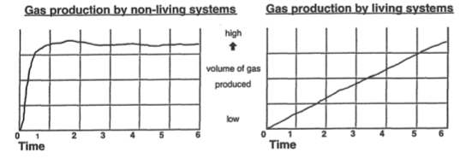
- The left plot looks like a chemical reaction. It began fast, went fast, and ended abruptly, as if one reactant chemical had been used up. It could be that the warm nutrient contained a chemical that reacted with a chemical in the soil.
- This looks like a living system! Gas production began slowly, built up, and is still continuing. It could be that the warm nutrient activated dormant life, much as water activates dormant brine shrimp eggs in soil.
- What would a combination of these two effects look like? Would that be easy or difficult to interpret?

1.5: Looking for Life Across the Stars

Overview
Students explore the basic concepts of spectroscopy in a short multi-station demo/game format
- Students try to guess the elements within four different spectra lamps
- Students also rotate through two stations designed to show the processes at work and how they can be used to determine the atmospheric composition of planets.

Materials
For the main instructor:
- sack of multi-colored photon balls
- moveable chalkboard with chalk
- chair and table
- laptop and access to computer projection equipment
- spectra keynote presentation
For the chlorophyll demo instructor
- chlorophyll demo (equipment and laptop)
- lithographs of planets/moons in our solar system (optional)
For each spectroscopy station
- spectra lamp with element bulb (see chart below)
- station marker
- spectra_page.odt
- an equal distribution of spectroscopes
For each student:
- Lab book
- pencils

Classroom action (60 min)
- Introduce (10 min). Explain that students will explore the fingerprints of substances; that individual atoms and molecules give off particular colors of light, and when you separate those colors into a rainbow, or spectrum, you can tell what something is made of.
- A scaled solar system (40 min total, about 6 min per station). Disperse teams among each station (there are six, so one group per station). Stations 1--4 are spectra guessing stations, stations 5 and 6 are explaining the physics of spectra and the chlorophyll demo, respectively.
- Stations 1-4: Students observe the spectra lamps through spectroscopes and guess in their notebooks what element is in the bulbs.
- Station 5: Explore absorption and emission spectra briefly.
  - Give a volunteer a number of photons, stand them at any excited level, and have them demonstrate emission spectrum by chucking photons at fellow team members. Elaborate explanations as necessary and draw diagrams on the board.
  - Give volunteer a number of photons, stand them at ground level, and have them demonstrate absorption spectrum by tossing them photons (another volunteer may do this). Elaborate explanations as necessary and draw diagrams on the board.
- Station 6: Show students the spectrum of chlorophyll. Describe how an alien civilization taking the spectrum of Earth could see this and know this substance was present on the surface. It is also a signature of life.
  - Elucidate the concept of biosignatures and give examples (O₂, CO₂, methane, etc.) as time permits.
- Results (10 min). Reveal the answers to the spectra guessing game:
Station | Element
1 | Mercury
2 | Helium
3 | Neon
4 | Hydrogen

- Students will earn one astrocredit for each correct answer (they should have worked in teams, so differences should be minimal).
- Dispense astrocredits.

Day 2: Life and Our Solar System

Introduction
In Day 1 we learned about the nature of life and the extreme conditions some of its hardiest examples can tolerate. How common might life be in the universe? To answer this we first look to our own backyard -- our solar system, and the worlds within it.
Today we’ll explore the solar system, its objects and distances, its formation and current state. We’ll learn what it means for a world to be habitable, and what worlds around us, if any, might qualify as such. This will help calibrate our expectations for how common suitably Earth-like worlds may be and help us ultimately find the source of the mystery message and answer the AstronoMystery.
2.1: Students will produce and act out a scale model of the solar system, examining the relative sizes, distances, and travel times of objects within
2.2: Students will make their own solar systems out of common household items and small changes to a single recipe
2.3: Students will investigate the various aspects of planetary habitability in a multi-station museum-like setting
2.4: Students will determine how habitable worlds of our solar system are, and what kinds of life, if any, might live there
2.5: Students will play Extremophile rummy, matching extremophiles to their current and hypothetical environments on Earth and elsewhere in the solar system

2.1: The Scale of the Solar System

Overview
Students are split into groups (2--3 groups total) to build and explore a scaled model of the solar system
- Students are provided scale beads of the planets and walk to scaled distances
- Students appreciate relative distances, sizes, and travel/communication times for worlds in our solar system

Materials
For each instructor:
- 8.5” diameter sun cutout
- box of planets (beads, balls, and pinheads)
- Planet trivia question cards
- stopwatch or timer
For each student:
- Lab book
- pencils

Classroom action (40 min)
- Introduce (5 min). Explain the concept of a scale model. We are effectively going to “shrink” the solar system down more of a terrestrial scale so we can appreciate interplanetary distances. We’ll learn more of these worlds later in the day.
- A scaled solar system (25 min). Start with the sun, and select a volunteer to stand and hold the sun cutout. Continue to walk with the remaining students and have them count paces to successive planets. For each planet, have them guess what planet is next and how many paces out it will be. You may also turn around and see how big the sun would be in the sky of your current planet.
- When the group arrives at a new planet, ask questions on cards. Whoever gets correct answers first gets to be planet. Remaining students can be asteroids. Keep describing properties of planets to fill time. Pacing instructions:
  - Sun: 8.5” cutout
  - Mercury: tip of silver pinhead. 10 paces (all walk)
  - Venus: white pinhead. 9 more paces (all walk)
  - Earth: white pinhead. 7 more paces (all walk)
  - Mars: silver pinhead. 14 more paces (all walk)
  - Jupiter: wood-colored ball. 95 more paces (all walk)- NOTE: probably stop here. Otherwise, it's about the distance of the last planet to the sun for the next number of paces.
  - Saturn: speckled yellow ball. 112 more paces (all walk)
  - Uranus: blue ball. 249 more paces
  - Neptune: blue ball. 281 more paces (all walk)
- Bring group back, but keep the Earth and Sun in position. Have the students guess the following:
  - End of the solar system: 10 football fields
  - Distance to Alpha Centauri: halfway around the world.
  - Rigel/Betelgeuse: Out to the actual Moon
- Now ask the students what the fastest thing in the Universe is. How fast is it?
  - Speed of light: about 1 inch/ sec.
  - Time to moon: about 1 sec
  - Time to Earth: 8 min. Have someone act out speed of light and walk from the Sun to the Earth that slowly.
  - At that rate, the student would make it around the world (scaled distance to the nearest star) in about four years.
- Discuss (10 min). How long does it take to communicate between worlds in our solar system? How long does it take to travel? Are planets farther apart than the students expected? Planets around other stars are much, much further away than that. Do you think this may help explain why we haven’t been visited or contacted? Why?

2.2: Make Your Own Solar System

Overview
Students make a model of the protoplanetary disk and form a “solar system” out of household items
- Students witness and model the formation of the solar system
- Students see how small differences in the recipe affect the result, indicating other solar systems may not be quite like our own

Materials
For each instructor:
- Clear, large round bowl with flat bottom (glass pie pan)
- Strainer for easy cleanup
- compost bin
- overhead projector
- laptop with access to computer projector equipment
For each team:
- Clear, large round bowl with flat bottom (glass pie pan)
- Water to fill bowl 1/2 to 2/3 full
- 1 heaping tablespoon of dried rolled oats (not instant oats)
- 2 heaping tablespoons of puffed rice cereal
- Pinch of black tea
- Large wooden spoon or other stirring stick
- Cups for oats, rice, and tea
- Marking pens
For each student:
- Lab book
- pencils

Classroom action (40 min)
- Introduce (5 min). We examined the sizes and dimensions of the present-day solar system in the last activity, but how did all these worlds form? Tell students that they will be using oats, puffed rice, and tea to model the formation of our solar system about 4.5 billion years ago. The oats and rice represent gas and the tea represents dust. Tell them that this simulation will help them see how scientists think the Sun, planets, and other objects in our solar system formed, beginning about 4.6 billion years ago.
- These models will be telescoped in size and time: Only a few moments of the activity will represent the 100 million years in which gases and particles come together to form the Sun, Earth, and other cosmic bodies in our solar system.
- Demonstrate (5 min). Go over the directions in the student logbook with students, demonstrating each step.
- Use the largest glass bowl or pie pan possible that will fit on an overhead projector. The bowl should be filled approximately 1 inch deep with water.
- Dump 1 tablespoon of oats into the water. The intention is to have them all sink, and they will after about a minute.
- Sprinkle the tea on the surface of the water, and then stir the water. The oats will clump on the bottom in the center, representing the Sun while the tea will clump on the surface, representing planets. Ask students to look for parts of the model that represent the Sun and the forming planets.
- Explore (15 min). Allow time for students to conduct the simulation and make their drawings in their student logbooks. Have them vary slightly the proportions of the ingredients.
- Discuss (15 min). Ask students to analyze what they saw. Did they see a central clump form? Were there other clumps forming that went around the central clump? If they didn’t see anything, stir the mixture again, then stop, and watch it swirl and form clumps. This can be repeated a couple of times before the water becomes too cloudy.
- How is this model similar to solar system formation? Swirling motion causes material to clump. One clump forms in the center, with several smaller orbiting clumps.
- How might it be different? Instead of gravity, the stickiness of the oats is causing it to clump together. Because of the temperature gradient in a real solar system, only dust exists close to the Sun, while gas and ice are present further out where it is cooler.
- How did the groups’ results vary? Did the outcome change based on the amount of material they used, the proportions involved, or how fast they stirred?What do they think this means? Should all solar systems be the same?

2.3: Habitability and the Solar System

Overview
Students will investigate several aspects of planetary habitability
- Students set up model atmospheres for an investigation of the greenhouse effect
- Students rotate through several stations to explore several key topics related to life in the universe
- Note: maintain up to 4 stations total based on volunteer availability, selected from the list following 2.3.1

2.3.1: Atmospheres: Global Greenhouses

Materials
For the instructor:
- laptop with access to computer projector equipment
- chalkboard or whiteboard
- dry ice (requires hammer and warm gloves)
- ammonia
- glass full of water
- control thermometer
- bottle transport box (and moveable cart)
- 2 teaspoons
For each team:
- 5-10 glass bottles of different colors if possible
- duct tape
For each student:
- Lab book
- pencils
- thermometers

Classroom action (20 min)
- Introduce (5 min). Nearly everyone has heard about the “greenhouse effect,” the natural process by which infrared energy (heat) is trapped in the atmosphere. The heat trapped by atmospheric greenhouse gases can raise the average surface temperature of Earth by 35 K (degrees Celsius). Venus presents an extreme example of the greenhouse effect -- its surface temperature is more than 450 ºC (over 900 ºF)! In contrast, the atmosphere of Titan, Saturn’s largest moon, warms the surface just a few degrees higher than if there were no atmosphere at all. It’s not just their distances from the Sun that causes this. If the Earth didn’t have an atmosphere, our surface temperatures would be like those on the moon, oscillating between 230 and -290 ºF. What role does the atmosphere have in retaining heat? What substance is the best at it? That’s what we’ll investigate.
- Note: the primary greenhouse gases are water (H₂O) vapor, carbon dioxide (CO₂), nitrous oxide (N₂O), and methane (CH₄). The greenhouse gas carbon dioxide is the most abundant chemical (96 percent) in the Venusian atmosphere. These facts should not be made known until later.
- Procedure (15 min). Have the students each select a bottle and decide what they want in it (just air, air and water vapor, ammonia vapor, or carbon dioxide.
- Have students take a reading of their thermometer and tape it to the inside of their bottle. Ideally, the thermometer should just be touching the bottle at the neck.
- Have students come up with several pieces of duct tape ready and request their atmospheric contents. Upon receiving them, they will seal their containers:
  - water/ammonia vapor: splash a few droplets inside.
  - carbon dioxide: place a small chunk of dry ice in the bottle. Make sure the student waits until the dry ice has sublimated before sealing the bottle.
- Have students place their bottles in the designated transport box
- Store for later. The lab facilitator will transport the bottles upstairs to the rooftop if weather permits. We will take measurements and analyze the results in a few hours.
- Place the bottles together in sunlight, either upright or on their sides (prevent them from rolling), and determine that they will not cast shadows on one another over the course of the experiment.
- Also, ensure the bulbs of the thermometers are not in direct sunlight.
- Place the open air thermometer alongside the bottles, also ensuring the bulb remains in the shade.

2.3.2-1: Station 1: The Habitable Zone

Materials
For the instructor:
- 3 different light bulbs of different wattages
- lamp
- meter stick
- 2 radiometers (several spares are also useful)
- extension cord
- whiteboard or chalkboard
- dry erase markers or chalk
- wheeled trays or smooth track for the radiometers
- optional: small ball or mini Earth model as a visual aid. Also habitable zone posters.
For each student:
- Lab book
- pencils

Classroom action (60 min/# stations)
- Introduce (2-3 min). The habitable zone is the range of distances from the star wherein water can exist in its liquid form on the surface of a planet. Liquid water is necessary for life processes, as we know them, to occur. If a planet is too close to the star, all water will evaporate. If it is too far away from the star, all water will freeze. Yesterday we talked about many different kinds of stars. How does the habitable zone vary among them?
- Explore (remaining time). Tell students they will be using the lamp in a simulation to find the habitable zones for different star types. Explain that the point at which the vanes of the furthest radiometer just begin to turn represents the distance from the star beyond which all water on a planet will freeze and the point at which the vanes of the closest radiometer turn 10 times in 10 seconds represents the distance from the star at which all water on a planet will boil and turn to vapor.
- Actual radiometer rates may vary based on the instrument and may be altered. Have a different student perform each task.
- To find the distance from a star where water will freeze, do the following:
  - Place one radiometer at the far end of the meter stick.
  - Make sure the radiometer’s vanes have stopped.
  - Gently move the radiometer toward the lightbulb.
  - When the vanes begin to spin slowly, stop moving the radiometer.
- Record the distance from the bulb to the radiometer on the board.
- To find the distance from a star where water will boil, do the following:
  - Continue moving the closest radiometer toward the light bulb.
  - Stop moving the radiometer every 10 cm and count the number of times the vanes turn in 10 seconds.
  - When you find the point where the vanes turn 10 times in 10 seconds, record the distance from the lightbulb to the radiometer on your Habitable Zones of Stars Data Chart.
- To find the life zone, subtract the boiling-point distance from the freezing-point distance. The answer is the width of the life zone. Record this number on the board.
- Repeat these measurements for each “star.”
- When done, plot these data on a graph similar to the one pictured.
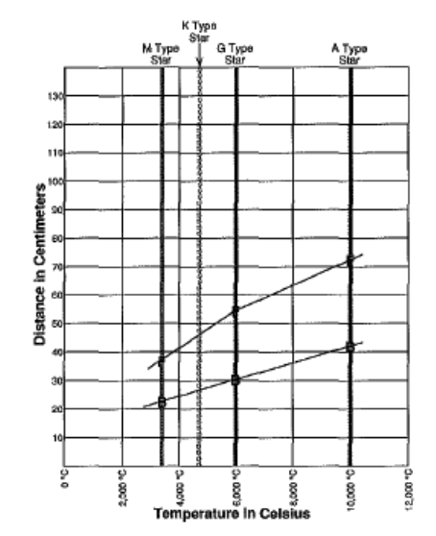
- Discuss the results with the students.
  - What do the students notice? What happens as the star temperature and brightness increases?
    - How far away does a planet need to be in order to be habitable?
    - What happens to the width of the habitable zone?
    - Dim red stars are the most common. Where should we look for planets around them?
    - What about stars like our Sun?

2.3.2-2: Station 2: Cratering Through Time

Materials
For the instructor:
- 3 shallow foil pans
- corn starch
- water
- flour and rice to fill 2 of the pans
- Moon ball
- crater poster
- golf balls
For each student:
- Lab book
- pencils

Classroom action (60 min/# stations)
- Introduce (2-3 min). Observations of the Moon and Mars show large variations between the amount of craters between different regions. We expect that every planet and moon was heavily bombarded and cratered in the early Solar System, so areas with few craters indicate the craters have been destroyed by some mechanism.
- Prior to the activity, mix cornstarch and water to make non-Newtonian fluid (NNF). Test consistency by hand.
- Explore (remaining time). As a group, the members should take turns dropping golf balls into the pan of flour. They should do this one at a time and under control, but they should keep going until they have covered a good deal of their landscape with craters. They should not aim, they should just let the craters be formed randomly.
- Compare their result to the Moon on the crater poster.
- Repeat with the rice and NNF. Comment on how these represent different types of rock and soil. Also shake pans to represent geologic activity. Does the Moon or Mercury appear to have much geological activity?
- Repeat once more with the Moon ball in the way of the golf balls. The represents having a Moon protect the Earth from additional cratering and allow complex life to evolve. Mention that having a massive, nearby satellite might be useful in allowing the evolution of intelligent life.

2.3.2-3: Station 3: Building Comets

Materials
For the instructor:
- comets poster
- dry ice
- cold weather gloves
- soil and spoon
- plastic cups
- corn syrup
- water
- ammonia
- paper towels
- plastic bags
For each student:
- Lab book
- pencils

Classroom action (60 min/# stations)
- Introduce (2-3 min). Comets are usually referred to as “dirty snowballs”. Most of the mass of the comet is water ice, but the rest is dust (or dirt) and other ices. As the comet approaches the Sun and heats up, some of the ices get converted to gas, creating a tail millions of km in length. Earth routinely passes through the (very low density) tails of comets, but in the early history of Earth (“The Late Heavy Bombardment” period), there were likely many collisions of comets and the Earth. These collisions may have seeded the early Earth with water, carbon dioxide, and organic matter. The combination of the material from comets and outgassing by volcanoes is what scientists think formed the oceans and atmosphere on the early Earth.
- Explore (remaining time). Make as many comets as time allows and have students help with including ingredients. Be sure to explain what each ingredient represents.
  - Double up two freezer bags by putting one inside the other.
  - Add about a cup of water to the bag.
  - Add about a half cup of dirt to the bag.
  - Add a dash of ammonia and a dash of corn syrup (this represents organic matter)
  - Add a cup of crushed dry ice to the bag.
  - Slowly compress the bag with your hands (wearing thick gloves to keep from getting burned).
  - Keep pressure on the ball until most of the water freezes and the ball feels hard like a solid snowball.
  - Remove the comet from the bag and place it on a wad of paper towels.
- Observe what happens to the comet as it melts (outgasses, sputters, emits jets of gas). Also break open the comet and observe that it is quite porous.

2.3.2-4: Station 4: Mars in 3D

Materials
For the instructor:
- Astrowall setup with 3D Mars show
- 3D glasses
For each student:
- Lab book
- pencils
- 3D glasses

Classroom action (60 min/# stations)
- 3D Mars (most of the time). Paraphrase the material below (written by Megan Catalano) or improvise your own description. Remember to emphasize habitability (or lack thereof) and why.
- This first slide depicts the entire surface of the planet Mars. This picture was made from data gathered from an orbiting satellite. The data gathered was in the form of altitude measurements, which means that each pixel in this picture has a height associated with it. For instance, the mountains poke out of the screen, while the craters look like potholes. A quick overview of craters – most of these were caused by meteoroids about the size of a car slamming into the surface of Mars and tossing out large amounts of dirt.
- Let’s compare the northern and southern hemispheres of Mars. At a glance, you’ll notice both halves are cratered, but the northern hemisphere looks a lot smoother than the southern hemisphere, which is heavily cratered. Let’s zoom in on the northern hemisphere. Anyone care to estimate the number of craters in this zoom? Toss out some numbers. It’s probably around several dozen or one hundred. Now let’s compare this number with the southern hemisphere. Again, what are some numbers? There are probably at least one thousand craters in this zoom, and some areas may have several thousand!
- Some of the craters have smaller ones inside of them. This means that an object caused the larger crater, and a smaller object later came along and impacted inside the original crater, making a newer, smaller crater. Every planet is cratered, including Earth. We don’t notice nearly as many craters on our planet, and there are several reasons for his. The edges may have been eroded, they may have been washed away or filled with water, or forests and jungles may be covering them.
- However, on Mars, the more cratered an area is, the more ancient the surface is. This means that the southern hemisphere is older than the northern hemisphere. There’s a very interesting reason for this!
- Let’s zoom in on what’s called the Tharsus Region. The most prominent feature here is Olympus Mons, an incredibly massive volcano. These three bumps to the southeast are also volcanoes. Olympus Mons is the tallest volcano in the Solar System, and is much bigger than any mountain on Earth. If we were to pick up the entire bulk of Olympus Mons and dump it on Earth, its base would completely cover the state of Arizona! There are cliffs on the top and side of Olympus Mons. Standing on the edge of these cliffs and looking down, you would note a four to six mile drop! The actual peak of Olympus Mons is between twelve and sixteen miles high.
- Around the volcanoes are ancient lava flows. We have more volcanoes over to the west, as well. In the northern hemisphere, lava flows have filled in the craters, which explain the smoothness of the surface here. For only the north to be filled in, the southern hemisphere must be higher than the north -- otherwise the lava would have seeped down over its surface and filled in its craters, as well.
- In the south is the Hellas Impact Basin, which is a massive crater. Its diameter is well over one thousand miles, and it’s the largest impact structure on Mars. An asteroid slammed into the surface and threw out a huge amount of dirt. To the east is another giant crater. Both of these massive craters raised the altitude of the southern surface of Mars.
- Now let’s check out Valles Marineris, a gigantic canyon. How many of you have ever been to the Grand Canyon? The Grand Canyon looks spectacular but pales in comparison to Valles Marineris, which, if placed on Earth, would stretch from New York to California! It’s also a few hundred miles across at some points.
- Now let’s get on the subject of Spirit and Opportunity, two golf cart-sized robotic geologists sent to Mars to look for evidence of ancient liquid water flows on the planetary surface. Above Valles Marineris is an interesting feature. Moving from left to right across it, we can trace out what seem to be channels and islands. It feels natural to us to assume they were carved out by eddies of flowing water, much like how rivers wind across the surface of Earth. It’s surface features like this that hint that water once flowed on Mars.
- Let’s find the landing area for the Spirit rover. We see a channel in the rock here, with a high point at its southern end and a low point at its northern end. If water flowed through this channel, it would move south to north and empty into Gusev crater, which was believed to once be filled with water, like a lake.
- On the rightmost edge of the image is where the Opportunity rover landed. It is called Meridiani Planum, and the composition of the soil here includes a lot of hematite. Hematite is a red-colored, iron-bearing rock which, at least on Earth, requires water to form. For scientists working on the Mars rover missions, it seemed the best bet was to head to hematite-rich regions and search for evidence of water flows there.
- Habitability (remaining time). Point out and discuss why Mars in uninhabited
- The planet is too small and can’t hold on to a substantial atmosphere
- Such an atmosphere shields organisms from harmful radiation and allows liquid water to exist at the surface (pressure and temperature)

2.3.2-5: Station 5: Life Under Pressure

Materials
For the instructor:
- Vacuum chamber
- clear bowl of water
- clear bowl with dry ice
- marshmallow peeps
- balloons
For each student:
- Lab book
- pencils

Classroom action (60 min/# stations)
- Introduce (2-3 minutes). It’s not just the contents of the atmosphere that are important to life, but how much of it there is. Ask students if they’ve ever seen the original Total Recall. Explain that living creatures don’t explode when exposed to low pressures, but they’re still crucial to the substances that make life work.
- Explain what the vacuum chamber is and what it is going to do.
- Explore (remaining time). Take turns individually putting the available substances into the chamber, depressurizing it, and see what happens.
- Show that water can boil at room temperature at low pressure. Have the students test the water afterwards and prove it is still at room temperature. What does this mean for the chances of complex life on a planet with low atmospheric pressure?
- Ask students what they think will happen before putting something new in the chamber.

2.4: Life in the Solar System

Overview
Students will research the prospect for life, simple, or complex, at various locations in the solar system
- Students examine lithographs, planetary trading cards, What’s the Difference, and Starry Night Middle School for clues to their assigned worlds’ habitability
- Students finish the ongoing greenhouse effect experiment and discuss

Materials
For the instructor:
- laptop with access to computer projector equipment
- chalkboard or whiteboard
For each team:
- Assigned lithographs and planetary trading cards (see assignment below)
- Extremophile rummy organism cards
- access to What’s the Difference and Starry Night Middle School in a computer lab setting
- logo card to assign seating
For each student:
- Lab book
- pencils

Classroom action (70 min)
- Introduce (5 min). We are all experts on our solar system, life, and the concepts of habitability. Now it’s time to combine all three. We know Earth is habitable, but what about other places in the solar system? What are they like? That’s what we will find out.
- Hunt (20 min). Each group will compare information on their lithographs and trading cards with the information of the most resilient extremophiles. They will also use the What’s the Difference and Starry Night Middle School software to see what these worlds look like up close. For the worlds they are assigned, they need to come up with a short, 2-5 minute (total) explanation of the following:
  - Where are we? Planet or moon?
  - Do you think something could live there? Complex or simple life? Why?
  - What’s it like there? Hot? Cold? What’s the atmosphere like?
  - What is the surface like? Does it have a surface?
  - Did you learn anything interesting?
    - Use WTD to figure this out
- Write those points on the board so the students can keep them in mind. Material assignments:
Group | Assignment | Lithographs | Trading cards
1 | Venus and Mars | Venus and Mars | Venus and Mars
2 | Mercury and the Moon | Mercury and the Moon | Mercury and the Moon
3 | Pluto, Charon, and Titan | Pluto/Charon, and moons of Saturn | Pluto/Charon and Titan
4 | Jupiter and Saturn | Jupiter and Saturn | Gas Giants
5 | Uranus and Neptune | Uranus and Neptune | Gas Giants
6 | Io, Europa, Ganymede, and Callisto | Moons of Jupiter | Io, Europa, Ganymede, and Callisto
- Students can split up assignments within their teams as they see fit
- Present and Discuss (30 min). Each group will take 5 minutes to go in front of the class to present their findings. While they are talking, run Starry Night Middle School and show all students the presented destinations.
- When they are finished, ask students if aliens could visit us from another world within our solar system.
- They should be convinced that Earth is very likely the only world in our solar system hospitable to intelligent, communicative life.
- Finish greenhouse experiment (15 min). Have students obtain their greenhouse bottles and measure their temperatures by looking inside or very quickly removing the thermometer. Write the control temperature thermometer on the board and draw a temperature axis horizontally.
  - Have students come up and draw symbols according to their experimental setup above their measured temperature:

Symbol (glass) |  | Contents (shading) -- leave blank if none
brown | circle | Water vapor | vertical
clear | square | CO₂ | horizontal
green | triangle | ammonia | crossed
- What atmospheric setup had the highest temperature relative to the control? Direct students fill out the remainder of 2.3 in their lab books.

2.5: Extremophiles: Life on the Edge

Overview
Students will play a card game that shows how life and conditions on Earth can be used as a model for life on other worlds.
- The rules are similar to rummy, and the game is best played within established teams
- Astrocredits are awarded to students based on how many cards they have remaining at the end of the play period

Materials
For the instructor:
- Astrocredit bank
For each team:
- Deck of extremophile rummy cards
- Paper and pencils for recording game play
For each student:
- nothing

Classroom action (40 min)
- Introduce (10 min). Explain the rules of the game:
- Deal five cards to each player and place the remainder face down between the players. This will be the draw deck . Turn one card face up next to the draw deck.
- The first player takes either the upturned card or the top card of the draw deck.
- The player sees if he or she has a set (one card from each category). To be a valid set, the organism must be able to live in the Earth and possible extraterrestrial habitats:
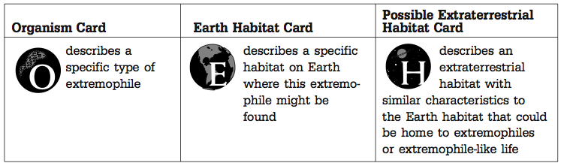
- If the player has a valid set, he or she must lay it down, read the three cards aloud, and explain why it is reasonable to think that an organism might exist on this other world. Other players can challenge the set if they disagree.
- The player discards a card and play continues in a clockwise rotation.
- The next player may take the discarded card or select the top card of the draw deck.
- Play continues until the first person goes out. Have the groups tally how many times each person wins within the play period.
- If all the cards from the draw deck have been drawn, shuffle the discarded cards and use them as a new draw deck.
- Play (20 min). Have the mentors audit the games for accuracy and cheating. Roam between the groups to assess progress.
- Award (10 min). Award all students astrocredits for participation; award the students with the most recorded number of wins a marginally higher predetermined amount.

Day 3: Stars in the Milky Way

Introduction

We’ve determined that, even in our own solar system, complex life may be quite rare. Many worlds in our own backyard are inhospitable to all but the sturdiest of microbes. But what of the worlds beyond?
When you look out into the night sky, you can see several planets with your own eyes -- Venus, Mars, Jupiter and Saturn, maybe even Mercury. We can glimpse Uranus and Neptune with a telescope, but worlds around other stars are too distant to be seen and studied directly -- at least for now. But what we do see are stars, and a lot of them. What can they tell us of intelligent life’s chance in the cosmic frontier? Today’s activities will cover stars, their properties, and how they might give us insight into the AstronoMystery.
3.0: Students will be introduced to stars in the night sky in the Planetarium
3.1: Students will explore the properties and longevity of stars in a large participatory H-R diagram
3.2: Students will act out the stages of stellar evolution
3.3: Students will be guided on a 3D tour of the Milky Way Galaxy
3.4: Students will compete in teams in Astrobiology Jeopardy before heading out to the pool for the rest of the day

3.0: Introduction

Overview
Students are introduced to today’s topic in the planetarium

Materials
For the instructor:
- Functional planetarium
For each student:
- Nothing

Classroom action (20 min)
- Introduce (5 min). Establish today’s topic. Now that we have determined alien civilizations can’t like on any other world in our solar system, explain that it is time to study worlds around other stars. But first we need to understand a little about stars themselves.
- The night sky (15 min). Point out planets and the moon. Show nightly motion of the stars.
- Outline some of the constellations that can be seen this time of year. What are these stars, how far away are they, and why do they all have different colors?
- Establish distances. Describe how the stars are hundreds of thousands to millions of times farther away from us than our Sun. If our Sun were the size of a volleyball, Earth would be the head of a pin across the room, and the Stars would be whole (real) Earths away.
- The Mystery Message. Explain that astronomers were working on localizing the message this week, and determined that it came from somewhere in the constellation Cygnus.

3.1: A Stellar Family Portrait

Overview
Students are split into groups (2--3 groups total) to explore the properties of stars in an oversized H-R diagram

Materials
For each instructor:
- Sidewalk chalk (if outside)
- Large paper and markers (if inside)
- several rolls of masking tape
- container with a set of star circles
For each student:
- Lab book
- pencils

Classroom action (50 min)
- Introduce (10 min). Astronomers like to plot different properties of celestial objects -- e.g. stars -- and see if there are any trends and what they might mean. Here, we’ll do the same with some of the stars you can see in the night sky. Draw on the sidewalk or on the large paper the axes of an H-R diagram (pictured below) and explain that these two axes, intrinsic brightness, and temperature are two things we can measure.
- If need be, establish the difference between intrinsic and apparent brightness
- Plot the stars (20 min). Have students select star circles from the container (make sure they are distributed evenly among them). Sharing the tape, they will plot these stars on the diagram, using the temperature and brightness axes to position them correctly. The purpose of this activity is to notice trends, so tell students not to get too bogged down in exact positioning of the stars on the plot, but to be careful that they place the stars in the right range, or else the patterns will get confusing.
- Have students copy the chart into their lab books.
- Discuss (20 min). Address these issues:
- Describe the general trend between temperature and brightness.
- What is the color and brightness of the most abundant stars? The rarest stars?
- What are the characteristics of the stars that do not conform to the graph’s trend?
- In terms of the graph’s trend, is our sun typical or exceptional?
- If you replaced the temperature scale on the graph’s x-axis with a color scale,
- which color would be closest to the graph’s origin and which would farthest away?
- In the stars that ﬁt the general trend (these are often called Main Sequence stars), what relationship do you notice between color and expected lifetime?
- Why might stars of one color be much more abundant than stars of another color? Since the red dim stars live the longest, there are many of them still around. The only hot blue stars we see are ones that formed in the past few million years. The others have already died off. These stars also form less frequently.
- Which type(s) of star should we consider first when looking for stars that might have life-supporting worlds around them? Why? Since our sun is a yellow star, this is a good place to start, and in fact this is where many extrasolar planet searchers are looking. The blue and white stars are often ruled out because they don’t live long enough for planetary life to begin and evolve very far before the star goes supernova. The red dim stars may not give off enough energy to support life easily on planets around them.
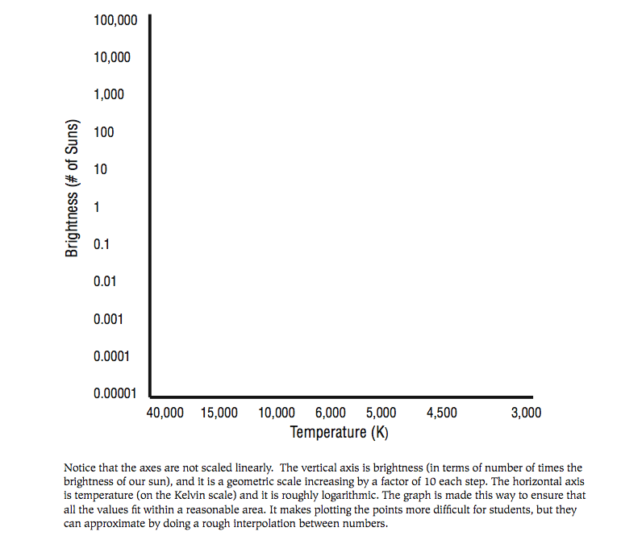

3.2: Stellar Evolution in Action

Overview
Knowing that stars can have vastly different properties largely based on their masses, students explore the differences in the life cycle of a low-mass (Sunlike) and high-mass star in 2-3 groups
- Students try to piece together the sequences of stellar evolution using snapshots
- Students act out the stages of stellar evolution

Materials
For each instructor:
- Numbered cards with various astronomical images/illustrations (from Chandra EPO resources)
- Chandra Stellar Evolution poster (not strictly necessary, but useful for end discussion)
For each student:
- Lab book
- pencils

Classroom action (70 min)
- Connect the dots (15 min). If you were an alien that came to Earth, how would you figure out how humans age? You just see a lot of different people in all directions, at different stages of their lives. Could you connect the dots? It's the same kind of thing for astronomers.
- Split students into a low mass group, and a high mass group (1:1 – 2:1 number ratio); challenge to put together sequence of evolution in 2 min. Note: Some are illustrations, some are images. There are different scales, colorations. Make sure the students work together, and give the specified cards below to the high-mass and low-mass groups (but shuffle them beforehand).
- Low mass sequence (approx. solar mass and below): 19– 3 – 10 – 1 – 21 – 5 – 14 – 25 – 26
- High mass sequence (approx. 8 solar masses and above): 22 – 7 – 23 – 16 – 17 – 11 – 9
- Stellar Evolution in Action (40 min)! Students will become a model that explains how stars live and die, and will recreate through their interactions live-action versions of the cards the just saw. Each person represents clumps of gas and dust many times more massive than the Earth.
- Follow the supplied outline (see the AER article on Kinesthetic Stellar Evolution for details). If there are 10 or more students total, have the high-mass and low-mass groups perform separately, and have the non-performing students observe and match what they see to the cards they have. If there are fewer than 10 students, have all of them perform both sequences).
- Be sure to note the interplay between gravity and gas pressure throughout the activity.

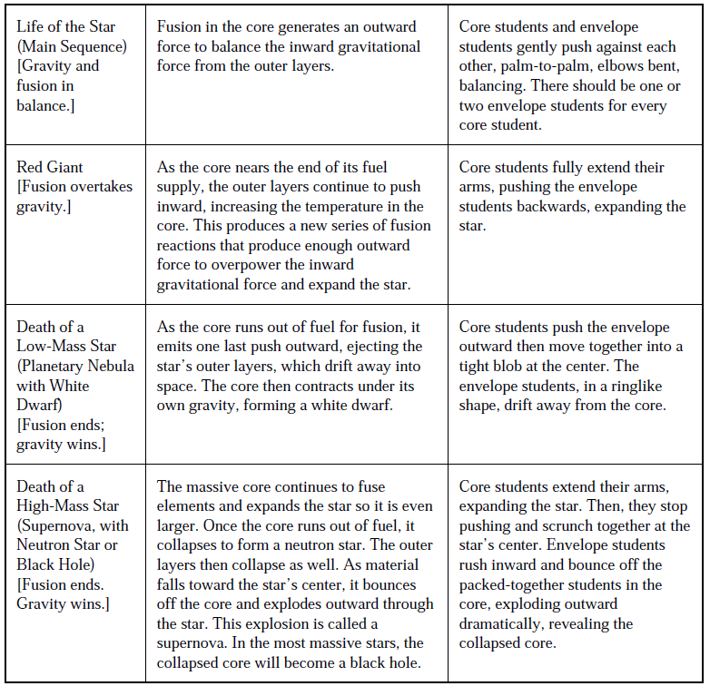
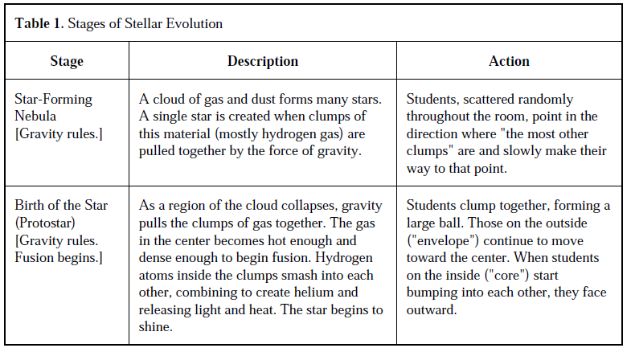

- Discuss (15 min). Use the Chandra Evolution poster to illustrate what the students modeled. Ask students to point out limitations of our model and what they have learned. Clear up any misconceptions they may have about the activity.

3.3: The Milky Way Galaxy

Overview
Students will be given a brief tour of the Milky Way Galaxy using the department Astrowall
- Students appreciate the distances between the stars and the timescales required for communication and travel
- Students see that we have closely studied a small fraction of the hundreds of billions of stars in the Galaxy

Materials
For the instructor:
- Astrowall and 3D Milky Way software
- 3D glasses
For each student:
- Lab book
- pencils
- 3D glasses

Classroom action (20 min)
- 3D Tour of the Galaxy. Roam through the Galaxy and point out the highlights, noting distances when possible. The following commands and outline may be useful:
  - g9 color const 0.4 0.5 1.0
  - stereo cross
  - stereo -0.01
- Start with stars and constellation lines. Deep sky objects and the Milky Way in visible wavelengths are shown.
  - g4 on
- Zoom out a bit; show distance scales
  - g4 off
  - g39 on
  - g40 on
  - g41 on
- See different types of stars
  - g1 see red
  - g1 see blue
  - g1 see bright
  - g1 see faint
  - g1 see all
- Zoom to Orion and see nebula. Show that constellations are “fake.”
  - g4 on
  - g16 on
- Return to sun, see exoplanets. Explain we will be exploring ideas behind these tomorrow.
  - g16 off
  - g4 off
  - g7 on
- Explain the disk of galaxy and its dust lanes. Show the MW in NIR.
  - g7 off
  - g39 off
  - g40 off
  - g41 – 44 off
  - g21 off (vis)
  - g26 on (dust from IRAS)
  - g26 off
- The ISM in different wavelengths
  - g22 on (atomic H)
  - g23 on (CO)
  - g22 off
- Newborn stars- OCs- H2 regions- Ha
  - g13 on (HII regions)
  - g27 on (recombination)
  - g23 off
  - g27 off
- Newborn stars. See Pleiades, Hyades, etc.
  - g13 off
  - g8 on (OCs)
  - g9 on (OB)
- Turn on galaxy and zoom out
  - g31 on
  - g8 off
  - g9 off
  - g39 on (...g40 – g44)
  - stereo -0.03
- Star orbits
  - g32 on
  - g32 off
- Bulge and GCs
  - g34 on
  - g10 on (GCs)
  - g10 off
- Zoom in to SS
  - g9 off
  - g8 off
  - g33 off
  - g34 off
  - g31 off
  - g41 – g44 off
  - g37 on
  - g38 on
  - g1 fov 0.005 [best to scroll manually to this level]
  - g17 on (Oort cloud)
  - g39 on
  - g40 on

3.4: Astrobiology Jeopardy

Overview
Students will solidify their knowledge of topics covered to date by playing team Jeopardy
- Students compete within their teams for astrocredits
- Students rotate within their teams after every question

Materials
For the instructor:
- Astrobiology Jeopardy game board with questions
- magnets or tape for affixing the game board
- dry erase markers for keeping score
For each student:
- Lab book
- pencils
For each team:
- Team logo
- answer buzzer/bell

Classroom action (25 min)
- Set up and explain rules (5 min). Have students line up single file in their teams , behind desks towards the front of the room. Give each team a bell and affix the team logo to the front of the desks, facing outwards.
- Rules: Decide on who is to pick categories first (e.g. pick a number between one and six). Read from the answer card and the first student to buzz in and give the correct question wins the advertised amount. He/she picks the next category/question.
- That round of students cycles to the back of the line and the next row of students compete in the next round.
- Repeat until sufficient time has elapsed.
- Play (20 min). A facilitator will keep score. At the end of the game, award a predetermined astrocredit amount for first place, and a slightly less amount for remaining students.

Day 4: Hunting for Distant Worlds

Introduction

We’ve learned about the nature of life and what it requires. We’ve explored the worlds in our solar system for life and found that, aside from Earth, they would only be home to the simplest, sturdiest extremophiles if they’re lucky. We’ve also looked to the stars and found that complex life is only possible around smaller, long-lived stars like our own. We also know that the mystery message came from somewhere in the constellation Cygnus. But where? And how can we find what world this transmission came from if it’s too far away to even see?
Today, students will learn one method of finding planets around distant stars -- the transit method. The Kepler satellite uses this method, conveniently also for stars in the constellation Cygnus. They will use this to pick out the star which most likely hosts our communicative interstellar neighbors.
4.1: Students will learn how transiting exoplanets are detected and how their sizes, masses, and orbital characteristics are inferred.
4.2: Students will look through real data from the Kepler satellite and try to find transiting planets
4.3: Students will learn how exoplanet transit light curves are translated into other properties and give insight into habitability
4.4: Students will take a break and play a “Sharks and Minnows”-style game
4.5: Students will explore the arrangements of other solar systems, their evolution, and their hospitality towards Earth-like worlds.
4.6: Students will apply their knowledge of planet transits to select a Kepler-studied star that has the best chance of having a habitable world around it with an intelligent civilization. This just might be the one that sent us the mystery message.

4.1: Detecting Exoplanets

Overview
Students learn about planetary transits and how they are used to find planets around distant stars
- Students learn how different orbits and planet sizes produce different light curves in a hands-on lab
- Students appreciate how the knowledge of a star’s mass and the planet period translates to planet distance via Kepler’s third law
- Students observe the lego orrery in action and a computer-generated light curve

Materials
For the instructor:
- laptop and computer projector equipment
- necessary keynote slides
- light graphing software
- lego orrery
- large paper for discussion
- markers
- Sun ball
- pin
For each team:
- 1 light meter
- 1 stand
- lamp with low watt (25 W) bulbs
- extension cords if needed
- ruler
- string
- scissors
- scotch or masking tape
- assorted beads of different sizes and shapes (must have holes drilled in them)
- 2 tables placed next to each other for extra table space
- calculators
For each student:
- lab books
- pencils

Classroom action (60 min)
- Discuss (5 min). Explain that there are many ways to look for exoplanets and this is only one method. Show images of the transit of Venus and ask what happens to the Sun’s light when something passes between it and us.
- Investigate (25 min). Walk the students step by step in the assembly a measuring process.
  - Assembly. Cut string into footlong pieces, and tie each piece to an individual bead. Tape securely if needed. When held by the string, the beads should hang loosely below.
  - Measure 30 cm radially from the central lamp in eight directions. Mark those positions with a piece of masking tape. Beyond one of those positions, mark a 60 cm distance with tape as well. Above view:
lamp
- Attach the light meter to the stand. Use clamps, tape, or whatever else is provided.
- Big beads vs. small beads. One student will measure the light output of the lamp with the lightmeter at the stationary outer position, while another student dangles a bead in front of the lamp at the inner eight positions. Make sure the lightmeter is held appropriately. One student will record these data and the rest will copy in their lab books afterwards.
  - Make sure the lightmeter readings stabilize before recording. Also explain the units involved.
lamp
LM
  - Students will do this for several beads of different sizes (switching positions between the experiments)
  - Walk students through graphing the result on the board. What is the difference between the big and small beads?
  - Explain the limitations of the model (the distance between lightmeter and bead, vs. bead and lamp).
  - Show relative sizes of Sun and Earth and ask students to predict how much light a transiting planet would really block.
    - Sun: sun ball (volleyball size); Earth: pin head; as viewed from between here and the (real) moon.
- Kepler’s Third Law (15 min). Explain that one orbit of the bead or planet is one year, or orbital period. Show that if you know the mass of the host star and the period of the orbit, you can get the distance of the planet to the star.
  - Define an AU in the process.
  - Show this using a human orrery. Have a few (2--3) students volunteer to be planets. The instructor is the star. Tell the first student to walk around him/her in an orbit at whatever speed the student likes.
  - Ask the class how fast the second student should orbit if the student is further away (faster, slower, or the same). Repeat for a more inward student.
  - If time permits, show the mathematics of Kepler’s third law: a³ = M p²
- The Lego Orrery (15 min). See Lego Orrery documentation (2011) for details. Set up the lego orrery computer light graphing software.
- Assemble the LEGO orrery that makes beads (planets) go in orbits (if it’s not already assembled).
  - Position the light (star) near the center of the planet orbits.
  - Mount and aim the light sensor to point at the star. It should be far enough away from the light that the planets do not hit it, but in general, the closer the better, even though this is one of the unrealistic elements of the model.
  - Connect the light sensor through the interface module and into the computer.
  - Start up the graphing software. Ideally, the experiment run time to at least 30 seconds. (in LoggerLite, this function is in the “Experiment < Data Collection” dialog box).
- Explain the parts of the model. The light is a star we are observing. The balls on arms that go around are planets orbiting the star.
- Do a test run of the software (Click “Collect” data) and demonstrate how graph behaves if something (like your finger) goes between the light sensor and the light. Optional: click on the Auto-Scale button (big letter A)
- Click “Collect” and then turn the crank to make the planets orbit the light (or have a volunteer do the cranking).
- Have the group analyze the resulting graph. Ask focusing questions such as: Can you tell how many planets there are just by looking at the graph? Can you tell the planets are different sizes? How? Which planet is closest to the star, the big one or one of the other(s)? How can you tell which planet is closest to the star?

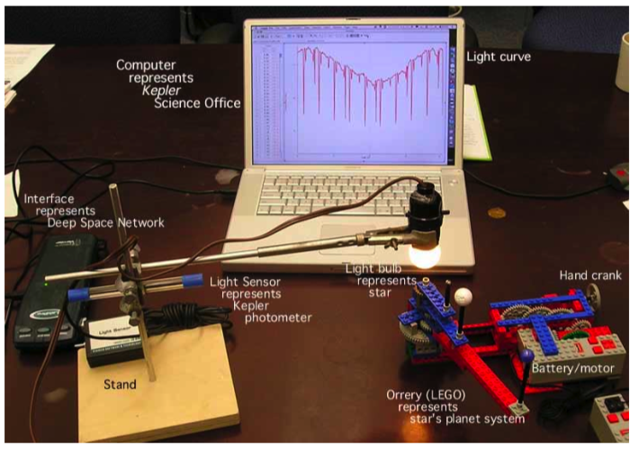

4.2: Hunting for Exoplanets

Overview
Students hunt for exoplanets using real Kepler data in an online interactive
- Students learn to pick out the regular dips of a transiting planet
- Students appreciate the “look” of “real” data

Materials
For the instructor:
- laptop and computer projector equipment
- zooniverse camp account (User name: ScienceU; Password SciU2014)
For each student:
- lab books
- pencils
- Access to http://www.planethunters.org/science in a computer lab setting

Classroom action (30 to 60 min)
- Set up (10-20 minutes). Guide students to log in to camp account and necessary tutorials. Explain that, now that they are experts in light curves and transiting exoplanets, it’s time to put that into practice with real planets and real data from Kepler.
- Introduce Kepler and its mission
- Explain the purpose of this citizen science adventure. Computers are great research tools, but the human eye can be better at picking out patterns.
- Have students create their own accounts.
- Investigate (remaining time). Allow students time to pick out their own planets and reflect in their lab books.
- Have students show their teammates when they’ve flagged a promising candidate.
- Students can explore other Zooniverse projects in their spare time.
- If Astro 001 games are available, groups can rotate to Astro 001 gaming stations one at a time (few minutes per group).

4.3: Are Exoplanets Habitable?

Overview
Students will investigate how light curves can be translated into planetary properties like size and temperature
- Students explore what happens to an Earth-like planet if certain characteristics of it or its host star are changed
- Students walk through an interactive that shows how light curves are measured and turned into the data we need to assess habitability

Materials
For the instructor:
- laptop and computer projector equipment
- Access to http://kepler.nasa.gov/multimedia/Interactives/keplerFlashAdvDiscovery/flash.cfm and http://184.72.55.19/system/interactable/1/index.html
For each student:
- lab books
- pencils
- Access to Access to http://kepler.nasa.gov/multimedia/Interactives/keplerFlashAdvDiscovery/flash.cfm and http://184.72.55.19/system/interactable/1/index.html in a computer lab setting

Classroom action (50 min)
- Extreme Planet Makeover (20 min). Ask students to list what would make a planet habitable to complex life (the right distance from the star, having a thick enough atmosphere, atmospheric composition, being the right size, etc), as was covered in Day 2.
- Guide students to log into computers and access Extreme Planet Makeover. They will click on the Earth preset.
- Have students explore what happens as they change the Earth’s size, its distance from the Sun, and the Sun itself
- Challenge them to make an Earth-like planet, but with a different setup of these characteristics.
- Kepler Exoplanet Transit Hunt (20 min). Have students go to the eponymous website.
- Walk through one of the planet hunts and explain how each step works.
  - Star info: What do we need the star’s mass and temperature (brightness) for?
  - Data collection: just like the orrery, but human-timed.
  - Distance: use Kepler’s 3rd law: a³ = M p²
  - Habitable zone position: uses the star’s brightness (temperature) and the planet’s distance (remind the students what the habitable zone is)
  - Surface temperature: calculated from the star’s temperature, size, and planet distance
    - T (K) = sqrt(( R_{star}/214) / (2a))
  - Radius: From the percent brightness drop in the light curve (Z) and the size of the star
    - R_{p} (Earth radii) = 10.9 * R_{star} * sqrt(Z)
- Have students do as many of the other stars that they can.
- Discuss (10 min). Are there any worlds that students would want to live on? What kinds of properties of the light curve should we look for in trying to find Earthlike worlds?

4.4: Nebular Sharks and Minnows

Overview
Students explore planet formation by playing a slightly modified version of Sharks and Minnows
- Students try to form or avoid being planets before the solar wind eliminates the protoplanetary nebula
- Students discuss the limitations of this game as a model

Materials
For the instructor:
- Orange traffic cones
- Astrocredit bank
- Planet “flag” bibs or pinneys (at least two colors; 15 of each)
For the seed students:
- Planet “flag” bibs or pinneys
For each student (post game):
- Nothing

Classroom action (30 min)
- Set up. Arrange traffic cones to make a large flat playing area. Have all but 2--3 mentors congregate in the middle with as the “Sun.”
- Designate 2--3 mentors as “seed planets” and have them go to distances roughly equidistant from the “Sun.” 2--3 campers will accompany them as the sharks. Have the remaining students spread themselves evenly across the playing field, the protoplanetary nebula. Non-playing students can assist the mentors in being the “Sun.”
- Explain the rules. The game is played just like sharks and minnows, except that there are no boundaries, and the minnows represent gas and dust in the swirling protoplanetary nebula.
- 2--3 mentors will slowly orbit the sun as the seed planets. The seed students stay within 20--30 feet of the seed mentor and tag as many minnows as they can. Remaining mentors will help referee from their central Sun position.
- Play. Play for approximately 5-10 minutes, in bursts of 20--30 seconds. After each round, the instructor dispenses flags to tagged players (color-coded by planet). All tagged players subsequently must follow the seed mentors as before, representing growing planetesimals in our solar system.
- After the play interval has elapsed, the instructor will sound the whistle, indicating that the Sun has begun to disperse the nebula with its solar wind. All remaining students will run out of the playing field.
- Dispense astrocredits to students:
- Winners (untagged students): ____
- Largest planet: ____
- Next largest planet: ____
- Discuss. In the time remaining, briefly talk about what aspects this game correctly and incorrectly models about how the solar system formed (compare to the earlier solar system formation demo )
- Timescales involved
- Relative and absolute sizes of model particles, planets, and Sun
- motion, orbits of bodies (angular momentum)
- number of planets

4.5: What Solar Systems “Work?”

Overview
Students investigate the stability and orbital properties of solar systems they build in an online interactive
- Students set up different solar systems and watch how they evolve over time
- Students establish that solar systems like ours are perhaps the “best” for planetary climate stability and complex life.

Materials
For the instructor:
- Laptop and access to computer projection equipment
- chalkboard or whiteboard (should be present in computer lab)
For each student:
- Access to http://www.alienearths.org/online/interactives/planet_families/index.php in a computer lab setting
- lab books
- pencils

Classroom action (40 min)
- Discuss (10 min). Ask why we have seasons and how regular they are. Correct students if they believe it is because we are at different distances to the sun at different times of the year.
- But what if this were the case, and what if our orbit around the Sun were elongated and/or irregular. What would happen to our weather?What kind of life (simple/complex) could best adapt to such an environment?
- Explore (20 min). Have students access the Planet Families interactive. Tell them to try building different solar systems (demonstrate one for them). Explain what planet most represents Earth, and what we want out of its orbit (not too close or far away; not too eccentric). Suggest these options on the board, and have students explore as many as they can in the time available:
- A solar system like ours (big planets far away, small planets close in). Repeat with a passing large planet or other star.
- Multiple Suns and a mixture of planets. Multiple jovian planets along with a few small ones. Hot Jupiters , then terrestrial planets.
- Wrap up (10 min). What kind of solar system is the “best” for developing an advanced civilization? How common do you think this is?

4.6: Who should we talk to?”

Overview
Students select the destination of their reply to the mystery message from several candidates, based on their new knowledge of light curves and the properties we infer from them
- Students measure the brightness drop and period of a set of Kepler planets and guess which world is “best”
- Secondary properties (Temperature and size) are automatically calculated by the instructor and a final candidate is decided upon.

Materials
For the instructor:
- Laptop and access to computer projection equipment
- planet_properties.odf spreadsheet
- Astrocredit bank
For each team:
- calculators
- set of candidate world light curves with star data on back
For each student:
- lab books
- pencils

Classroom action (35 min)
- Discuss (5 min). Present these candidate worlds to the students, implying that our astronomers culled the sample of candidate planets and selected these ten as the possible source of the mystery message. Now they need our help.
- Measure and guess (15 min). Have the students measure the % brightness drop of the transits and the period of the orbits by hand. Can they guess based on this information what the best option would be?
- Compute (15 min). Use the planet_properties.odf to calculate the key planetary properties -- temperature and size (express that this is an average surface temperature based on some assumptions, not an absolute). By a show of hands, which world is the best now?
- Awards astrocredits to the groups that guessed correctly. Award slightly less to all other groups.
- Tomorrow, we’ll come up with something to say to our potential alien neighbors!

Day 5: Life in the Universe

Introduction

In day 4 we identified the best candidate solar system of several surveyed in the direction of the mystery message. To do this we learned how to hunt for exoplanets using the transit method, examining the light curves of the host stars for miniscule, well-timed dips that indicate a reasonably terrestrial world was present. We are also sure that this planet lies in the habitable zone of its comfortably long-lived star.
Today, students will explore several issues in communicating with any extraterrestrial civilizations that may live there:
5.1: Students will decipher the mystery message
5.2: Students will answer the Astronomystery with the Drake equation
5.3: Students will hypothesize and sketch the alien world and its potential inhabitants
5.4: Students will collectively formulate a message to send to said inhabitants.
5.5: Students will prepare for the awards ceremony, where they will present what they have learned to a backdrop of pictures obtained in the camp thus far.

5.1: Communicating Across the Galaxy

Overview
Students decipher the message received in the opening ceremony. Goals:
- Students learn “ideal” ways to encode messages
- Students recognize the difficulty of communicating across language and cultural barriers
- Students appreciate the distances and timescales involved in interstellar conversation

Materials
For the instructor:
- Laptop and computer projector equipment
- Access to http://morsecode.scphillips.com/jtranslator.html (speed: 5 wpm)
- Code 1: EEETEEEEETTTEEETTTTTEEETTTEEEEETEEE
- Speakers/computer audio
- Large paper and markers for discussion
For each team:
- Scissors
- Scotch tape
- Calculators
- Markers
- Arecibo binary string printout (pass out later)
For each student:
- Lab book
- pencil
- Test message bubble sheets (2 per student)

Classroom action (70 min)
- Discuss (10 min). Go over this background information with students. Review how far away the selected star from Day 4 is in light-years.
- What would a signal from an extraterrestrial civilization be like? The extraterrestrials probably would not know any Earth language. Their transmitter would be very far away, and their signal may be weak. It might be very simple, nothing more than a series of pulses, repeated over and over, like the call sign on a radio or television station.
- How would you broadcast a message, in pulses, to somebody who does not know your language? Could you create a message in a code so simple that the person receiving it would surely figure it out, even an extraterrestrial who knew nothing about you? The exercise that follows imagines that we on Earth have received a message in this kind of code.
- When we first met, we had just received a mysterious signal from outer space. We now know that this signal probably came from _______, or rather a planet orbiting that star. Your challenge now? You must decipher the message!
- Activity: Practice Message (20 min). before they begin deciphering the longer, simulated message, the class will work on the practice message, which contains 35 bits of information. For this simulation, explain that the radio telescope was aimed at the star Tau Ceti and was tuned to a single frequency. An observer listening with earphones heard a signal loud and clear above the static. Record this signal.
- Go to morse code translator site and play code 1
- The challenge for the extraterrestrial senders and the human receivers is to convert the string of tones into something that both can understand, even though they have no common language. This exercise shows a scheme devised by SETI researchers for reading such strings of data. Students should make two copies of the same message so that they may experiment with several arrangements of the data.
- Student sheets should look like this:
- Hints: How many dots are there? (There are 35.) Is there anything special about this number? (It is a product of two prime numbers, 5 and 7.) Can you arrange them in a way that would make sense other than in a straight row? (Yes.) Go ahead and try other ways of arranging this series of dots. You have two sets so that you can try both ways. The practice message will look like the image below after it is decoded in both of the possible ways.
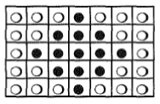
- Importance of primes. Data is arranged into rectangular arrays to look for picture messages. But rectangles can have many dimensions. A data set of 24 bits could be arranged six different ways: 2 x 12, 12 x 2, 6 x 4, 4 x 6, 8 x 3, 3 x 8. A longer data string would have many other possibilities, unless the length of the string (e.g., 35) is the product of two prime numbers (5 x 7 or 7 x 5). Then, there are only two possible rectangular arrays for the data which makes decoding the message much simpler.
- Activity: “Actual” Message (40 min). Review the hints given to the students via twitter/facebook all week and stated here:
  - 2-dimensional
  - prime numbers
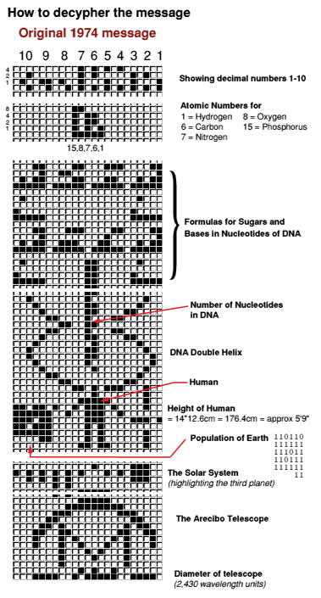
- The mystery message is 1679 bits long. Challenge the students to come up with the dimensions of the image (23 x 73). They can use calculators.
- Pass out the Arecibo binary strings. Have students cut out each row of 23 bits and tape them together in a 2D image. Also have them fill in the ones with marker (zeros are empty; this gives the appearance of a scantron sheet).
- What does it mean? Challenge students to interpret what they see.
- The reveal. Provide keynote image of the colorized message for clarity. Explain that this message was actually one sent from Arecibo in 1974 as part of a re-commissioning ceremony. This transmission did not actually come from our target solar system.

5.2: The Drake Equation

Overview
Students will frame their answers to the AstronoMystery with the Drake equation
- Students will summarize and discuss what they have learned from their investigations thus far and posit answers to the AstronoMystery
- Students will use the Drake Equation to estimate the number of communicating interstellar neighbors we may have in the Galaxy.
- Students appreciate the distances and timescales involved in interstellar conversation

Materials
For the instructor:
- Large paper and markers for discussion
- Large tub of sand and 7 smaller transparent containers
For each team:
- Calculators
For each student:
- Lab book
- pencil

Classroom action (50 min)
- Discuss (10 min). Ask students what topics we have covered this week (Astronomy, planetary science, biology). Write these down on the board.
- What have we covered so far that would help explain the absence of aliens around us? Conversely, what have we covered so far that would lead you to believe there should be aliens around us? Examples:
  - Many worlds may be uninhabitable by anything but extremophiles (Day 1-2)
  - Only certain stars may have suitable worlds around them (Day 3)
  - Pleasant solar systems like ours may be relatively rare (Day 2 and 4)
  - Planets need to be in habitable zones for complex life to evolve (Day 4)
  - Space is vast and maybe difficult to traverse (Day 2--3)
  - He don’t have the technology to detect proper biosignatures yet and know for sure (Day 1)
  - There appear to be many examples of exoplanetary systems; planets should not be rare
  - Life appears just about everywhere, at least on Earth
  - Maybe they’re just not that interested in communicating in general, or talking to us in particular.
- Examine (10 min). In 1961, the astronomer Frank Drake suggested an organized framework for thinking about life in the Galaxy. Known as the Drake Equation, his work provides a way to estimate the number of worlds within our Milky Way that have intelligent life and whose radio transmissions should be detectable. Drake organized the issues like that the students have listed into eight terms to help people make an educated estimate: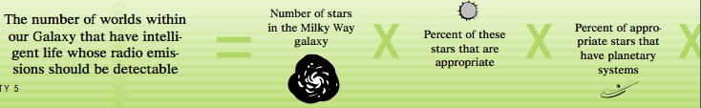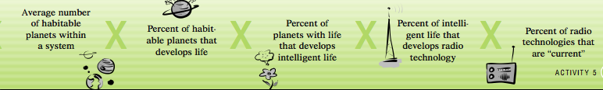
- Write this equation on the board and leave space below for many different estimates of the terms.
- What does this mean? Illustrate to the students that this is like taking the total number of stars in the Galaxy and scooping out a fraction of those stars with each term. Begin with the tub of sand to represent all the stars in the Galaxy (several hundred billion -- far more than can be found on any one beach).
- Estimate (20 min). Have each group make its own estimate in the lab books (students will fill in the “Background” section):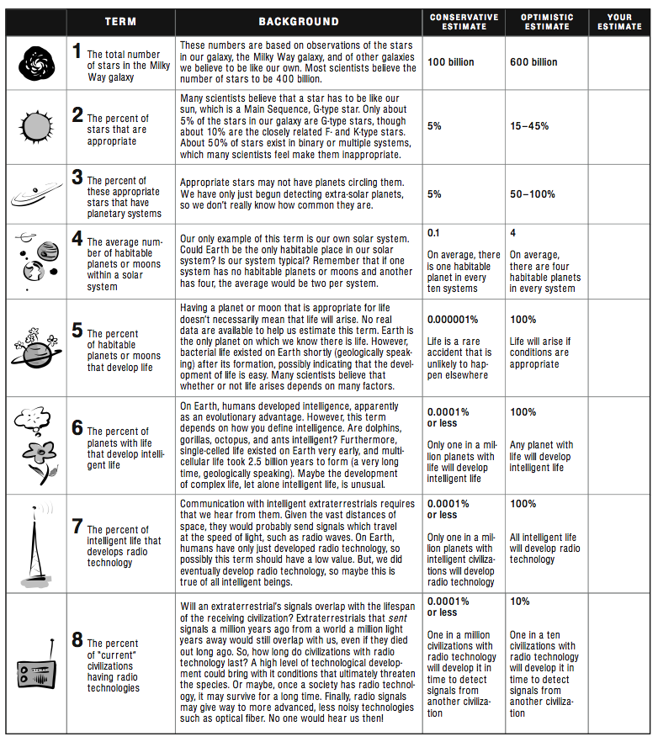

- Each group will multiply the terms together and come up with a final number.
- Have each group appoint a spokesman to come up to the board and write down their estimates for each term and final result.
- Does this make sense? (10 min) If the final answers are close to 1, that would explain why we haven’t been contacted yet. If the answers are millions or billions, we should have been contacted.
- In which terms do we have the least confidence? The most confidence?
- Discuss possible reasons for our silent skies:
  - Are we tuned to the right frequencies? Would anyone try to communicate via radio?
  - Communication and direct contact are different. Will we ever meet anyone face to face?
  - Would advanced civilizations even care about us?
- Time filler: Can you make a “better” equation? Knowing what we know now, are there terms that Drake omitted? Can you come up with an equation that explains why we are or seem so alone?

5.3: Who are We Talking to?

Overview
Students will draw the alien world they have detected and its possible habitants, based on what they know about it.
- Students will apply prior knowledge of this world (mass, radius, surface temperature)
- Students will express creativity in speculating about how complex life could adapt to such an environment.

Materials
For the instructor:
- Large paper and markers for discussion
For each team:
- Art supplies (colored pencils, markers, art paper, rulers)
For each student:
- Lab book
- pencil

Classroom action (40 min)
- Discuss (5 min). Although we haven’t actually detected a signal from this putative world, we have still selected a candidate planet for hosting extraterrestrial life, and right in our Galactic backyard. Let’s say hello!
- Have students list what they know of this world.
- Create (35 min). Ask students what do they think this world looks like? What could its inhabitants look like?
- Is the planet warm and humid like a rainforest or hot and arid like a desert? Is it cold and snowy, or nice and temperate?
- How would aliens have had to evolve to adapt to such a world? Pay attention to gravity and temperature.
  - Mention bilateral symmetry, convergent evolution, or other concepts in evolutionary biology that would be helpful here.
  - Explain that their pictures will be shown during the awards ceremony. Have the students sign and date their work.

5.4: Interstellar Pen Pals

Overview
Students will discuss if, how, and why they will send a message to the target world, along with what they will say.
- Students will apply knowledge and skills learned in 5.1 to this problem
- Students will work together to create one message as interstellar ambassadors

Materials
For the instructor:
- Large paper and markers for discussion
- Laptop and access to computer equipment
- opaque hat-like container (drawing names from a hat)
- audio recording equipment (Morse code recorder: http://www.robertecker.com/hp/research/morse-generator.php?lang=en; or use Audacity on instructor laptop for voice messages)
For each student:
- Lab book
- pencil
- graph paper
- ruler

Classroom action (70 min)
- Discuss (10 min). What should we say? Should we say anything? Will it hurt to reveal ourselves?
- Points to address:
  - Do we risk annihilation by speaking up?
  - What’s the best way to communicate? Through spoken words, or images? Keep in mind we’ve been broadcasting for decades now. If one civilization had access to all those signals, it probably could understand us by now.
  - Do we want to say anything, or merely initiate the conversation with a friendly hello?
- So what should we say (10 min)? We probably can’t transmit a photograph, but a simple binary string that can be reconstructed as an image, or an audio file will do. Briefly brainstorm with the class what we think is important to reveal about ourselves, or to prove our transmission isn’t random noise.
- Let’s say it (30 min)! Have each student write/draw his/her own message (10 min).
- Have a class discussion to come up with a group message and record it (20 min).
  - Pick a name out of a “hat” to decide who gets to record. Students will have written their names on a scrap piece of graph paper.
- Prepare for the awards ceremony (20 min, or remaining time). Assign each group a day or number of activities to summarize (5 minutes or less for each presentation) at the awards ceremony. Explain that slides with pictures of them in the activities will be presented at the same time. Students may appoint one person to say a sentence or two about each activity, or have one person speaking on behalf of the group. Remember to emphasize what they learned from the experience.
- Bathroom breaks are also suggested.
- Creative means of expression (e.g. singing) are also encouraged.

5.5: Awards Ceremony

Overview
Parent/guardians (PGs) and students will attend a joint arts show and awards ceremony to commemorate the (hopefully successful) camp.
- PGs will admire student artwork
- Instructor introduces camp and thanks key personnel
- Students will summarize their experiences in camp and receive main prize
- Students can exchange astrocredits for additional prizes

Materials
For the instructor:
- Laptop and access to computer projection equipment
- access to keynote/ppt and http://ed.ted.com/lessons/why-can-t-we-see-evidence-of-alien-life
- Main prizes (Galileoscopes)
- Keynote or powerpoint slides with camp photos loaded (1 slide per activity/timeslot; about 25 slides)
- Prize table with prizes and prices indicated.
For each student:
- Lab book

Classroom action (60 min)
- AstroArt Exhibit (10 min). Direct PGs to look at student artwork.
- Direct Introduction (10 min). Introduce and thank everyone involved.
- Student presentations (30 min). Students present their summaries; instructor parses through slides.
  - To close, show the TED clip.
- Prize exchange (remaining time). Exchange astrocredits for prizes. PGs can take students’ artwork on their way out.

Nighttime Observations

Objective
On the first available clear night or preferably Friday night, the Astronomy Department will host an open house event allowing rooftop access and telescope observation. Students and parents are encouraged to attend.
- Guests observe prominent summer evening objects of interest. Kepler stars are indicated with Kepler star wheels.
- If this event occurs on Friday, prepare one of the telescopes with the laser communicator and “broadcast” the prerecorded group message.

Materials
For the instructor
- fully laptop with recorded message
- broadcast equipment
- RA and DEC of selected world (look up beforehand)
For the outreach coordinator
- Rooftop access
- Available working telescopes
- Ephemeris
For the outreach volunteers
- Kepler star wheels (enough to hand out)
- observing lasers

Classroom action (60-120 min)
- Set up (45 min before). Set up telescopes. Attach broadcast equipment to most functional, astrometrically accurate telescope. Communicate to volunteers the main goals of the evening:
  - Show students and parents an overview of the current night sky (constellations, planets, stars, objects)
  - Send message to selected world
- Observe (60-120 min).
- Broadcast (15 min). Once a sufficient number of people have arrived and the target source is at high altitude, send the message.

